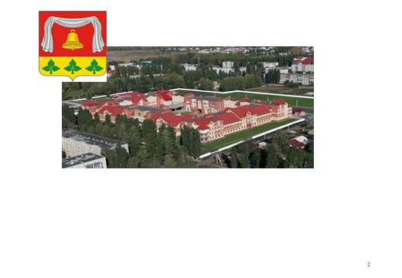

AHA C E N T N O Y N A OF THE YEAR S. S. V. O T R NOT VERY NOT VERY N. A. R E Y M. S. M. K. V. G. NOT VERY NOT NOT NOT NOT NOT NOT NOT NOT NOT NEW G. G. K. L. A NEW VERY T A B B A Y K. S. V. T. S. L. M. NOT NOT NOT NOT

The year 2024

**1. General information of the municipality**

**1.1. Geographical location. The area of the territory**

Climatic conditions Pervomaisky Municipal District is located in the Central European part of the Russian Federation, in the northwestern part of the Tambov region.

The district belongs to the Oka-Don geomorphological region, it is a flat, poorly divided plain with a pronounced microrelief. The territory of Pervomaisky municipal district is 941 square kilometers.

The district borders with: the southern part of the district - Michurinsky municipal district, the western - Lipetsk region, the northern - Ryazan region, the eastern - Staroyuryevsky municipal district.

The administrative center of the Pervomaisky municipal District is the Pervomaisky settlement. The Pervomaisky work settlement is located at the Bogoyavlensk junction station of Russian Railways.

The distance from the district center to the regional center is 110 km. The distance to the capital is 350 km.

There are 42 settlements in the district: Pervomaisky village, Ilovai-Dmitrievskoye village, Staroe Kozmodemyanovskoye village, Novoe Kozmodemyanovskoye village, Podlesny village, Khobot - Bogoyavlenskoye village, Novo-Arkhangelskoye village, Kolbovka village, Novy Mir village, Paris Commune village, Cheryomushka village, Novoklenskoye village, Novobogoyavlenskoye village,Novoseslavino village, village of Annenka, village of Zaryadnaya Dubrava, village of Mikhaylovka, village of Nikolskoye, village of Polevoy, village of Khobotets – Vasilevsky, village ofZavodskoy, Brigadier forestry, village of Ilovai - Brigadirskoye, village of Novospasskoye, village of Fonvizino, village of Ivano-Pushchino, village of Zmeevka, village of Staroklenskoye, village of Maly Snezhetok, village of Ozerki, Department of the Snezhetok state farm", Staroseslavino village, Khobotets -Vasilyevskoye village, Khobotovo village, Vostochny village", Ilovai - Rozhdestvenskoye village, Ivanzhitovo village, Sofino village, Stepanishchevo village, Chernyshevka village, Dobry Put village, Lychnoye village.

31 localities are connected to the county center by paved roads. The following settlements do not have paved roads: Sofino village, Prutsky village, Podlesny village, Novy Mir village, Annenka village, Zaryadnaya Dubrava village, Mikhaylovka village, Dobry Put village, Khobotets - Vasilyevsky village, Ozerki village, Polevoy village, Brigadir forestry.

The natural conditions of the district are characterized by moderate continentality, the average temperatures in July are 19-22 °C, January is 8-11 °C, the amount of precipitation ranges from 400 to 550 mm per year, and the duration of the growing season is 175-185 days.

[The hydrographic network is represented by the following rivers: Ilovai, Sukhoi Ilovai, Vishnevka, Alyoshnya. The district is located in a forest-steppe zone. There are many ponds on the territory, which serve mainly as a source of water for household needs. Climatic conditions and natural resources are favorable](https://translate.yandex.ru/translator/%D0%A0%D1%83%D1%81%D1%81%D0%BA%D0%B8%D0%B9-%D0%90%D0%BD%D0%B3%D0%BB%D0%B8%D0%B9%D1%81%D0%BA%D0%B8%D0%B9" \t "_blank)

[for agriculture.](https://translate.yandex.ru/translator/%D0%A0%D1%83%D1%81%D1%81%D0%BA%D0%B8%D0%B9-%D0%90%D0%BD%D0%B3%D0%BB%D0%B8%D0%B9%D1%81%D0%BA%D0%B8%D0%B9" \t "_blank)

**1.2 Resource and raw material potential**

There are 2 mineral deposits on the territory of the district, 1 of which is a place of occurrence of loam for brick production (Staroklenskoye deposit (located 2 km south-east of Snezhetok railway station, 10 km south-west of Bogoyavlensk station), 1 deposit of building sands (Mokhovaya site) is located 0.5 km away southwest of Mokhovoye village).

[The district has fertile chernozem soil.](https://translate.yandex.ru/translator/%D0%A0%D1%83%D1%81%D1%81%D0%BA%D0%B8%D0%B9-%D0%90%D0%BD%D0%B3%D0%BB%D0%B8%D0%B9%D1%81%D0%BA%D0%B8%D0%B9" \t "_blank)

[There are two objects on the territory of the district that belong to the landsof natural science: two geological monuments of the Devonian period of the Paleozoic era, located on the territory of the Khobotovsky forestry, and a unique forest plantation (Ranenburgskoye), located on the territory of the Khobotovsky forestry.](https://translate.yandex.ru/translator/%D0%A0%D1%83%D1%81%D1%81%D0%BA%D0%B8%D0%B9-%D0%90%D0%BD%D0%B3%D0%BB%D0%B8%D0%B9%D1%81%D0%BA%D0%B8%D0%B9" \t "_blank)

**1.3. Environmental situation**

In modern conditions, the problem of ecology is in one of the most important places. The main components of this problem are the state of the atmospheric air and the water basin. Protection of water bodies and their use is of high priority.

In Pervomaisky municipal District, water resources are represented by surface and underground water bodies. Due to the intensive growth of industrial production, the discharge of contaminated wastewater is an acute problem

6 enterprises are responsible for the environmental situation in the district.

The agricultural lands of the Pervomaisky municipal District are environmentally friendly, and the products produced on them are environmentally friendly.

Pervomaisky municipal District has an advantageous geographical location at the intersection of highways, a favorable environmental situation, rich natural resources and climatic conditions in central Russia, which is conducive to development.

**2. Population and social sphere**

**2.1 Population and labor force structure**

The permanent population of the district as of 01.01.2025 amounted to 23.5 thousand people, by the level of 2023 – 99,2% (23,7 thousand people), including rural 13.1 thousand people or 55,7%.

The population density per square kilometer decreased from 26.8 people in 2019 to 25 people in 2024. In the total population, persons of retirement age are: in 2019 - 35.4%, in 2020 - 35%, in 2021 - 34.3%, in 2022 - 34.4%, in 2023 - 34.6%, in 2024 – 34,9%.

|  |  |  |  |  |  |  |  |
| --- | --- | --- | --- | --- | --- | --- | --- |
| The name of the indicator | Ed. ed. | 2019 | 2020 | 2021 | 2022 | 2023 | 2024 |
| The average annual number of people employed in the economy, including: | thousand people | 4,685 | 5,027 | 4,933 | 5,091 | 5,056 | 5,127 |
| Agriculture, forestry, hunting, fishing and fish farming | as a % of the total | 28,5 | 28,5 | 33,0 | 35,8 | 34,3 | 35,5 |
| Manufacturing industries | as a % of the total | 19,8 | 16,4 | 12,3 | 12,5 | 12,2 | 9,6 |
| Provision of electric energy, gas and steam; air conditioning; water supply; sanitation | as a % of the total | 2,5 | 2,8 | 1,4 | 1,0 | 1,0 | 1,3 |
| Wholesale and retail trade; repair of motor vehicles, motorcycles | as a % of the total | 3,4 | 3,4 | 3,5 | 3,4 | 4,3 | 4,2 |
| Activities of hotels and catering establishments | as a % of the total | 0,3 | 0,7 | 0,6 | 0,5 | 0,5 | 0,5 |
| Transportation and storage | as a % of the total | 4,7 | 9,7 | 9,7 | 9,6 | 8,7 | 8,6 |
| Financial and insurance activities | as a % of the total | 0,2 | 0,3 | 0,2 | 0,8 | 1,1 | 0,5 |
| Activities related to real estate transactions | as a % of the total | 0,7 | 1,1 | 1,1 | 1,1 | 1,3 | 0,6 |
| Public administration and military security, social security | as a % of the total | 7,9 | 7,3 | 7,3 | 6,9 | 6,9 | 8,0 |
| Education | as a % of the total | 16,7 | 15,5 | 15,7 | 14,6 | 13,0 | 12,7 |
| Activities in the field of health and social services | as a % of the total | 9,4 | 8,7 | 9,2 | 8,0 | 7,9 | 8,8 |
| Activities in the field of culture, sports, leisure and entertainment | as a % of the total | 1,2 | 1,2 | 1,2 | 1,1 | 1,2 | 1,2 |
| Provision of other types of services | as a % of the total | 4,7 | 4,4 | 4,8 | 4,7 | 7,6 | 8,5 |

**2.2 Social characteristics of the population**

|  |  |  |  |  |  |  |
| --- | --- | --- | --- | --- | --- | --- |
| The name of the indicator | 2019 | 2020 | 2021 | 2022 | 2023 | 2024 |
| The number of people of working age, thousand people | 12,7 | 12,4 | 12,3 | 12,3 | 12,3 | 12,3 |
| Number of employees per unit of occupied territory, people/sq. km | 4,9 | 5,4 | 5,3 | 5,4 | 5,4 | 6,0 |
| The unemployment rate is the ratio of the number of unemployed to the economically active population, % | 0,48 | 0,58 | 0,55 | 0,46 | 0,3 | 0,2 |
| The average monthly nominal salary of workers in the economy, RUB. | 29943 | 33366 | 38641 | 42606 | 47048 | 55573 |
| Housing provision of the population, sq. m., on average per inhabitant | 31,8 | 33,2 | 33,8 | 34,4 | 35,2 | 36,2 |

**2.3. Healthcare**

The network of medical institutions of the Pervomaisky municipal district is represented by the following medical institutions: Pervomaisky CRH, the center for general medical practice (family medicine) in the village of Khobotovo, the center for general medical practice (family medicine) in the village of Staroseslavino, the center for general medical practice (family medicine) in the village of Ilovai-Dmitrievskoye, the office of the general practitioner (district) in the village of Staroklenskoye, the office general practitioner (district) s.Ilovai-Brigadirskoe,

15 FAP.

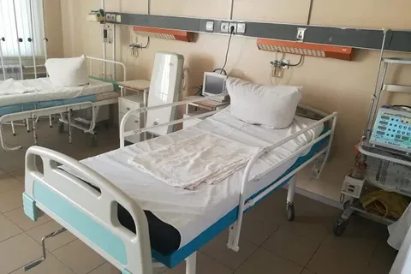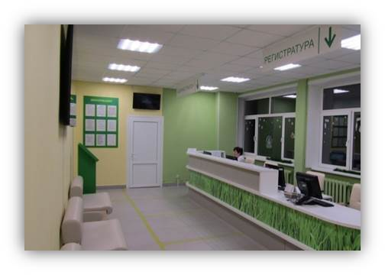

The Pervomaiskaya CRH has 84 round-the-clock beds and 20 day hospital beds. The hospital admission rate was 5.1 per 100 people.

Modern diagnostic and treatment methods are widely used for the treatment of patients in hospital settings: ultrasound, X-ray, endoscopic, laboratory diagnostics, physiotherapeutic methods of rehabilitation of patients.

Average number of visits to doctors per district resident per year in 2024, it was 4.0.

Provision of doctors is 73.4%, and secondary medical personnel is 93.4% of the employed rate.

The level of coverage of all population groups by preventive medical examinations remains high every year. In 2024, 16.4 thousand people were examined, of which: 3.8 thousand children, 1 person is a veteran of the Great Patriotic War, 59 people are combat veterans, 3 people are disabled in combat, 8 people are veterans of military service.

In order to provide benefits for the villagers, the general practitioner and internists travel to rural health facilities on schedule.

|  |  |  |  |
| --- | --- | --- | --- |
| Pervomaisky Municipal District Healthcare Institution | Address | Director | Telephone |
| 1.Tambov Regional State Budgetary Healthcare Institution Pervomaisk Central District Hospital of Pervomaisky Municipal District of the Tambov Region | 393700, Tambov region, Pervomaisky district, 2 a Hospital street | Queen  Nina Alexandrovna | 2-12-56 |

**2.4.Education**

The preschool education system in the municipal district is represented by the Pervomaisky Kindergarten MBDOU with 5 branches, 3 preschool departments and the organization of variable forms of preschool education education on the basis of MBOU "Pervomaisk secondary school".

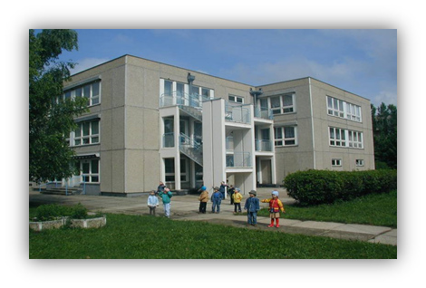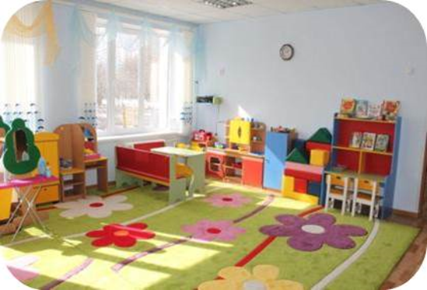

In total, 909 preschool-age children are enrolled in various forms of preschool education in the district.

The availability of preschool education is ensured both through the functioning of kindergartens and through the development of variable forms of preschool education: pre-school classes, a Play support center for children, preschool mini-centers, Counseling centers for parents and children raised in family conditions, family groups, and adaptation groups.

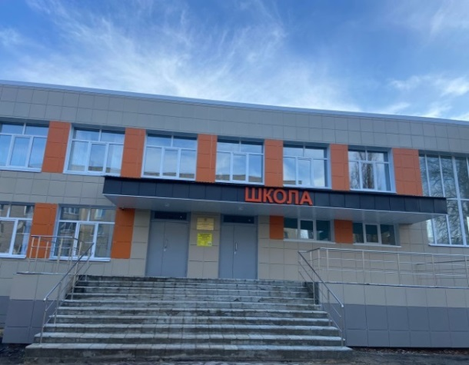 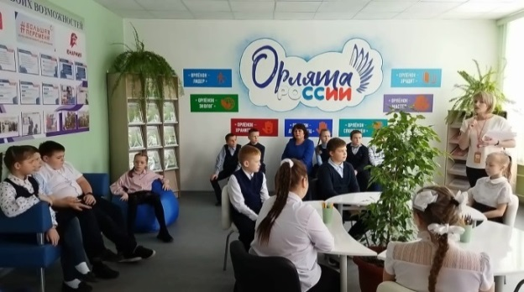

In the municipal district, there is a general education institution MBOU Pervomaisk Secondary school with 15 branches (in addition, 3 more branches of Pervomaisk Secondary School implement only a pre-school education program). The school and its branches have a student population of 2,395 students, and 175 classes.

The educational system employs 412 teaching staff, of which 66 are young teachers, which is 16% of the total number of teaching staff. The centers of digital and humanitarian profiles "Point of Growth" operate in the educational building No. 1 of the Pervomaisk Secondary School and in 10 of its branches.

All schools are provided with high-speed Internet access, have up-to-date anti-terrorist security passports, video surveillance systems and alarm buttons with the transmission of alarm messages to the remote control of the department of non-departmental security.

There are 6 patriotic clubs, 8 unarmee detachments, 16 primary branches of the Movement of the First, 20 volunteer detachments, 12 school museums, and 19 memory corners in Pervomaisky municipal district. The Eaglets of Russia project is being actively implemented and the All-Russian Public and state Movement of Children and Youth "Movement of the First" is developing. Currently, there are 903 "eaglets" in the Pervomaisk school, and 1,255 activists who are members of the All–Russian Public and State Movement of Children and Youth, the Movement of the First. The volunteer direction of youth policy is developing.

The system of additional education in Pervomaisky municipal district is represented by 3 institutions of additional education and the implementation of educational programs for additional education in the Pervomaisky Secondary School and preschool educational institutions.

|  |  |  |  |
| --- | --- | --- | --- |
| The largest  educational institutions of Pervomaisky municipal district | Address | Director | Telephone |
| 1. Municipal budgetary educational institution "Pervomaisk secondary school" | 393700,  Tambov region,  M.O.Pervomaisky,  R.P. Pervomaisky, Telman str.,5 | Gruzdeva Lydia Alekseevna | 2-17-62 |
| 2. Municipal budgetary preschool educational institution "Pervomaisky kindergarten" | 393700,  Tambov region, M.O.Pervomaisky, R.P. Pervomaisky, Druzhby str.,11 | Zhilin Svetlana Nikolaevna | 2-18-17 |
| 3. Municipal budgetary educational institution of additional education "House of children's creativity" | 393700,  Tambov region, M.O.Pervomaisky, R.P.Pervomaisky, Lenin Square,4 | Kiyanova Ludmila Mikhailovna | 2-38-30 |
| 4. Municipal budgetary educational institution of additional education "Pervomaisk children's and youth sports school" | 393700,  Tambov region, M.O.Pervomaisky, R.P. Pervomaisky, Sovetskaya str.,202 | Moiseev Alexander Alexandrovich | 2-38-03 |

MBOUDO "House of Children's Creativity" is attended by 400 children; MBOUDO "Pervomaisk Children's and Youth Sports School" - 697 children, MBOUDO "Pervomaisk Children's Art School" - 260 children.

**2.5. Culture and sports**

The cultural sphere of the Pervomaisky Municipal District is represented by 4 municipal institutions: the Central House of Culture, which includes 15 branches; the Central Library, which includes 20 branches; the Children's Art School; the Pervomaisky Museum of Local Lore.

MBU "Central House of Culture" has clubs, amateur associations and clubs of interest – 231 units, of which: for children -90.

In 2024, 3,227 cultural events were held. Special attention is paid to the patriotic education of young people, the revival of folk festivals and rituals.

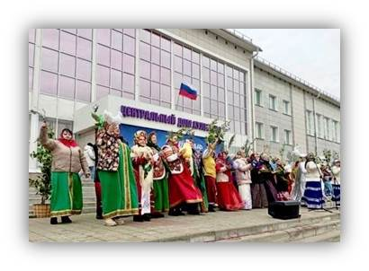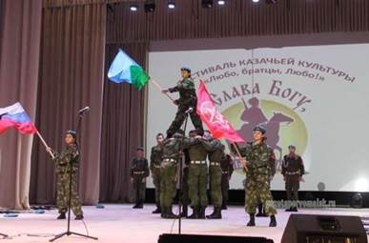

MBU "Central Library" of Pervomaisky municipal District provides library and information services to the population of the district and unites 20 (public) public libraries.

The total library stock of MBU "Central Library" is 189.7 thousand copies.

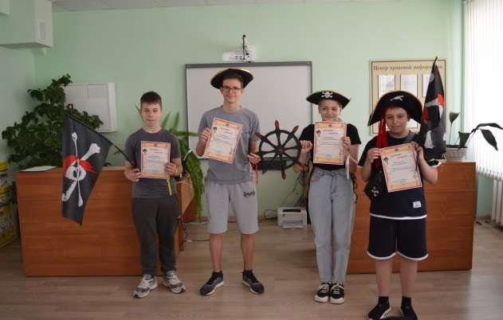 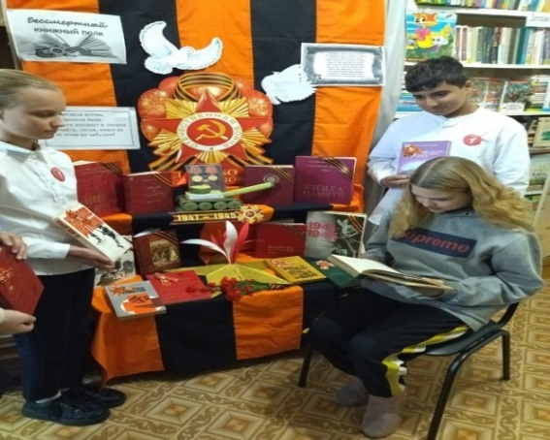

MBOUDO Pervomaiskaya DSHI implements general educational programs: in the field of musical art – "Pop singing", "Choral singing", "Early general aesthetic development of preschool children"; musical instruments – "Piano", "Accordion, bayan", "Guitar". DSHI students have repeatedly become winners and prize-winners of international, national, and regional competitions and festivals.

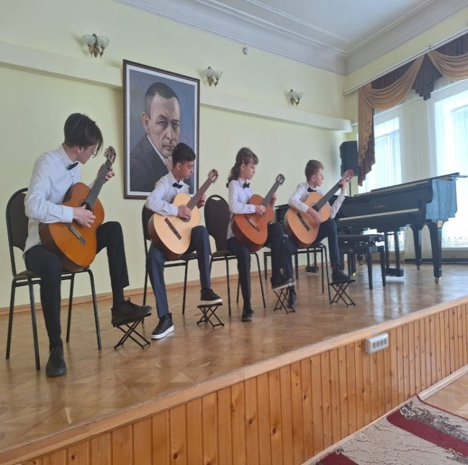 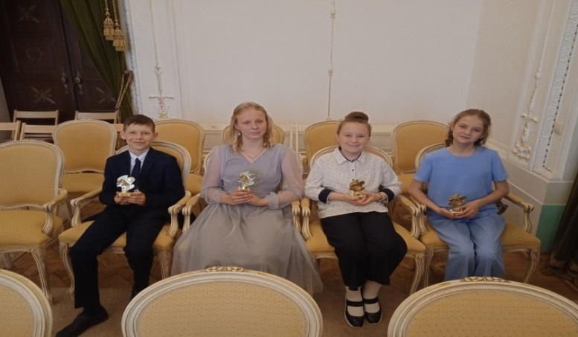

During 2024, an employee of the Pervomaisky Museum of Local Lore carried out work on accounting, storage, and study of exhibits in the museum's collections. 23 exhibitions from its own fund and 49 guided tours were held.

As of 01.01.2025 The main stock was 2,435 units of storage.

The main collections are "Paintings", "Numismatic objects", "Documents", "Photographs and negatives", "Printed items", "Items of technology", "Objects of archeology".

|  |  |  |  |
| --- | --- | --- | --- |
| The largest cultural institutions of the Pervomaisky municipal district | Address | Director | Telephone |
| 1. Municipal budgetary institution "Central House of Culture" | 393700,  Tambov region, M.O.Pervomaisky, R.P.Pervomaisky, Lenin Square,4 | Rebrina Olga Borisovna | 2-38-02 |
| 2. Municipal budgetary institution "Central Library" | 393700,  Tambov region, M.O.Pervomaisky, R.P.Pervomaisky, Lenin Square,4 | Gorina Alla Nikolaevna | 2-16-34 |
| 3. Municipal budgetary educational institution of additional education "Pervomaiskaya children's Art School" | 393700,  Tambov region, M.O.Pervomaisky, R.P. Pervomaisky, Druzhby str.,6 | Bondarenko Natalia Vyacheslavovna | 2-13-46 |
| 4. Municipal budgetary cultural institution "Pervomaisky Museum of Local Lore" | 393700,  Tambov region, M.O.Pervomaisky, R.P. Pervomaisky, Druzhby str.,1 | Petrishcheva Elena Vitalievna | 89158645455 |

For the organization and conduct of mass sports and physical culture and recreation activities in the district there is: 1 stadium, 14 gyms, 110 playgrounds and fields, of which: 9 standard hockey boxes and 3 tennis courts, 20 built-in and adapted facilities for physical education and sports.

As part of the national project "Demography" of the regional project "Sport is the norm of life", a football field with artificial turf was built at the Fakel stadium, and major repairs of running tracks were carried out. The construction of stands is planned.

Percentage of the population systematically engaged in physical education and sports (3 - 79 years old) It is 57.5%.

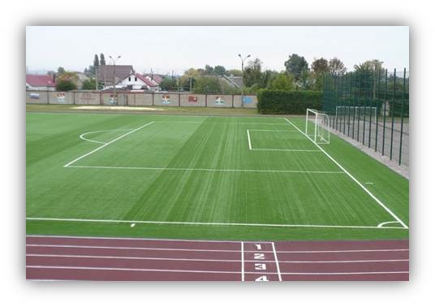 *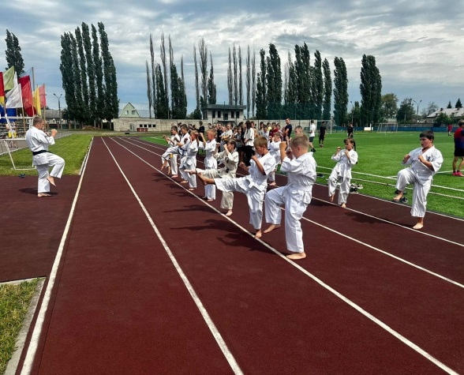*

**3. Infrastructural potential**

**3.1 Transport system**

The total length of public roads in the territory of Pervomaisky municipal district is 822.66 km, including the length of local roads – 761.6 km.

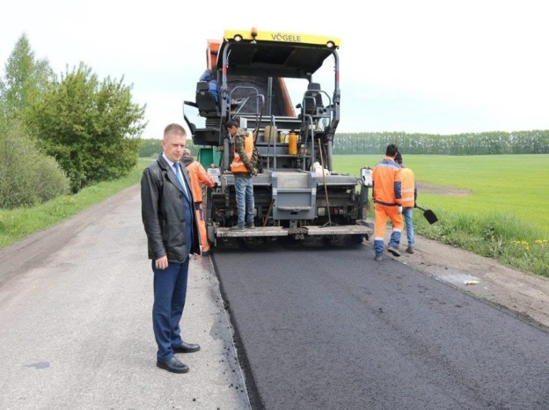 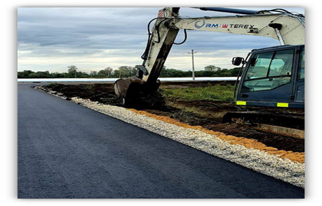

On the territory of Pervomaisky municipal district passenger transportation on seven routes is carried out by LLC "CREW". Cargo transportation is carried out by enterprises that have cargo transportation, as well as by entrepreneurs who own trucks that have been registered and licensed for cargo transportation.

**3.2 Communications and telecommunications**

The population of Pervomaisky municipal district is served by Pervomaisky post office of the Federal Migration Service of the Tambov region, a branch of the Federal State Institution "Russian Post". Public telephone services are provided by Rostelecom PJSC.

The number of telephone settlements was 43.

There are 4 mobile service providers in the district: Beeline, MTS, МegaFon, Tele2.

The coverage of the population by television broadcasting is 100%.

The level of development of modern communication systems in the district is quite high, which is a factor that increases the competitiveness of the territory and promotes business development using modern information technologies.

**3.3 Energy supply**

There are 221 transformer substations and 1,013.4 km of electrical networks located on the territory of the municipal district. The Northern Distribution Zone of the branch of PJSC ROSSETI Center - Tambovenergo is engaged in the provision of electricity supply services.

**3.4 Gas supply**

Gasification of settlements and social and cultural facilities continues in the municipal district.

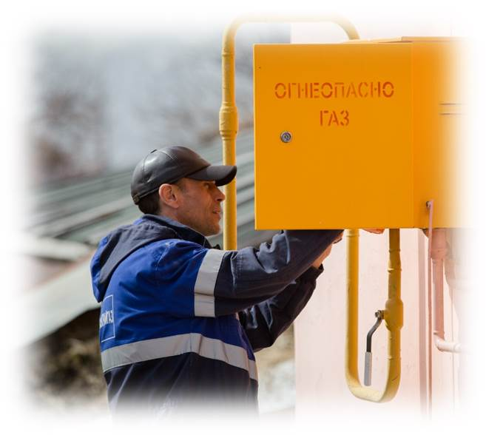

As part of the gasification program, 133 households were gasified in the Pervomaisky Municipal District in 2024.

**3.5 Water supply**

The length of the district's water supply networks is 272 km., network wear is 80-90%. In the territory of the district, Aquatech LLC provides a service to provide the population with drinking water.

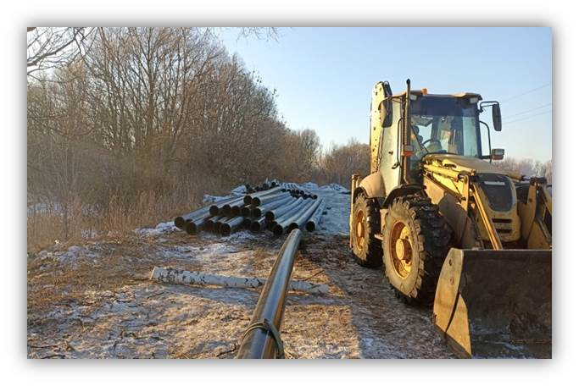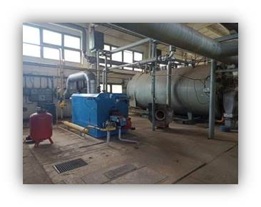

**4. The economy and the situation in the real sector**

**4.1 The share of Pervomaisky municipal district in regional socio - economic indicators, %**

|  |  |
| --- | --- |
| Naming of indicators | The specific weight of the district |
| area of the territory | 2,7 |
| population | 2,5 |
| investments in fixed assets | 1,1 |
| the average number of employees of enterprises and organizations | 2,6 |
| number of students in full-time educational institutions at the beginning of the school year | 2,5 |
| sown areas of grain crops | 1,4 |
| sunflower seed areas for grain | 0,8 |
| potato acreage | 3,1 |
| livestock, at the end of the year |  |
| - Cattle | 1,3 |
| - pig | 0,04 |
| production |  |
| - meat of all kinds | 11,4 |
| - milk | 1,1 |
| - eggs | 1,0 |

**4.2 Agriculture**

Agriculture makes a significant contribution to the economic development of Pervomaisky municipal district.

The agro-industrial complex of the district is represented by two large holdings LLC Agrotechnologies and LLC Cherkizovo, which are the main landowners of the district, the fruit farming company LLC Snezhetok and the processing enterprise JSC Starch Products.

The farming sector in the district is not significant. There are 23 farms in the district, including 5 livestock farms and 2 greenhouses.

In recent years, the agricultural sector has demonstrated steady growth in production, investment, and wages.

 

The sown area for the 2023 harvest was 39.9 thousand hectares, which is 2.1 thousand hectares more than last year.

Intensive horticulture continues to develop as a priority area for agricultural development.

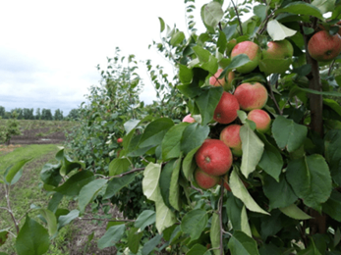 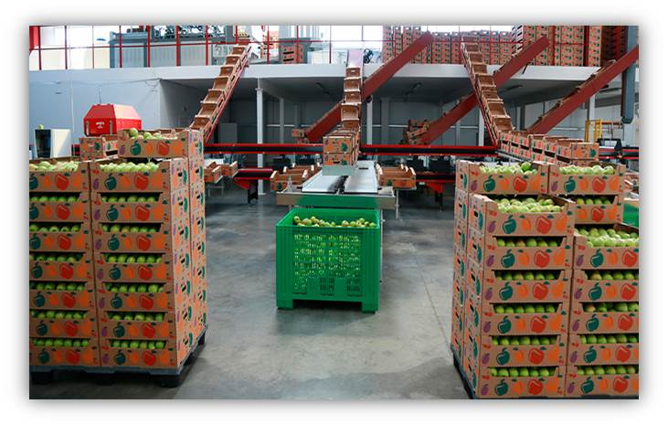

A modern fruit storage facility allows you to save fruits until the new harvest, in terms of building another fruit storage facility.

Livestock production accounts for almost 70% of the gross agricultural output in value terms.

The number of livestock as of 01.01.2025 was: Cattle – 983 heads (90.8% by 2023), including cows - 400 heads (85.1% by 2023), pigs - 370 heads (83.5% by 2023), poultry – 1.79 million units (99.0% compared to last year).

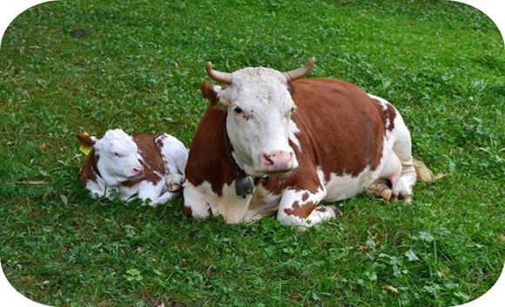 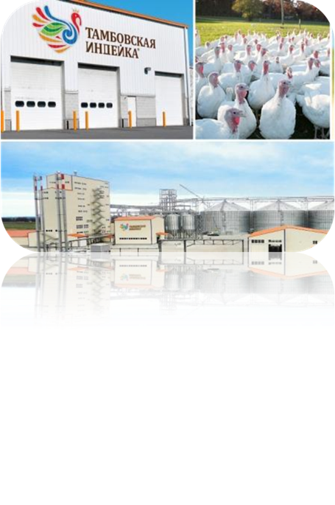

In 2024, 73.8 thousand tons of meat were produced, or 128% of the level of 2023. Milk production (farms and farms) amounted to more than 2 thousand tons, or 86.8% compared to last year. The main prospect for the development of agriculture in the municipal district is a complex for the production and processing of poultry (turkey) meat LLC "Tambov turkey".

** **

**4.3 Industry**

Large and medium-sized enterprises of the municipal district sold industrial products and provided industrial services in the amount of 4,7 billion rubles (111.6% compared to the corresponding period of 2023).

More than 95% of the volume of industrial products sold is accounted for by the food industry - JSC Khobotovo Enterprise Starch Product.

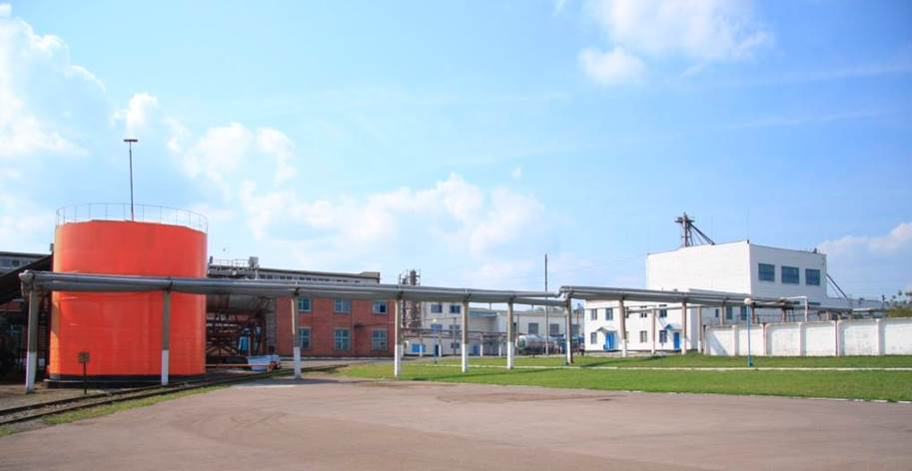 

The volume of products sold by JSC Khobotov Enterprise Starch Products increased by 10.1% compared to 2023 and amounted to 4.5 billion rubles. Agrofarm LLC, a feed protein production company, operates on the territory of the district. The volume of products sold by this enterprise in 2024 increased by 26.9% and amounted to 160.4 million rubles.

**4.4 Construction**

[The construction of individual housing continues. As of 01.01.2025, 5914 square meters of housing were commissioned. As part of the implementation of the Youth – Affordable Housing subprogram of the Pervomaisky Municipal District municipal program "Providing affordable, comfortable housing and communal services to citizens of Pervomaisky Municipal District of the Tambov Region" for In the beginning of 2024, 4 certificates of the right to receive social benefits for the purchase of residential premises or the creation of an individual housing construction facility in the amount of 3742.2 thousand rubles were issued, of which the budget of the Pervomaisky Municipal District is 3.4 thousand rubles.](https://translate.yandex.ru/translator/%D0%A0%D1%83%D1%81%D1%81%D0%BA%D0%B8%D0%B9-%D0%90%D0%BD%D0%B3%D0%BB%D0%B8%D0%B9%D1%81%D0%BA%D0%B8%D0%B9" \t "_blank)

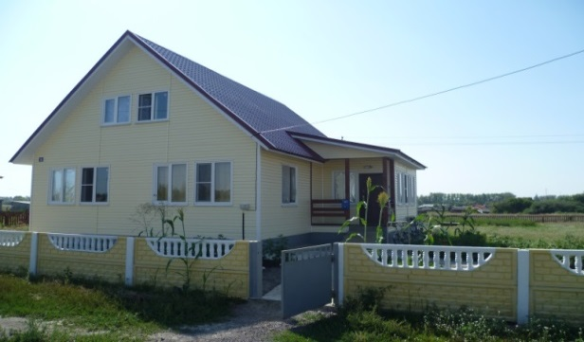 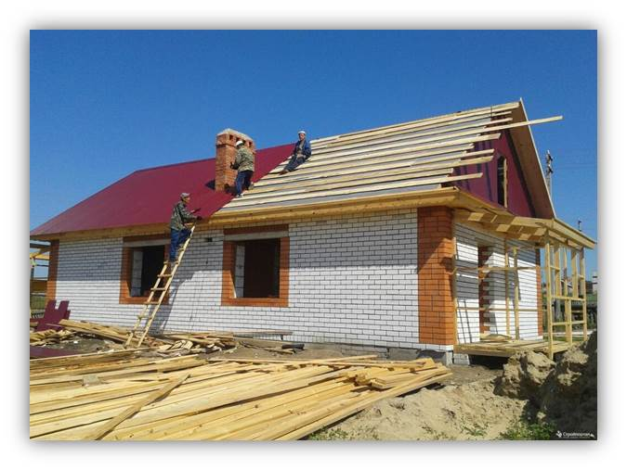

**4.5 Innovations**

There are currently no scientific centers for the introduction of modern technologies in the territory of the municipal district, but innovative methods of work take place in the district.: -JSC "Starch Products" - technical re-equipment and modernization of the existing equipment fleet; -Snezhetok LLC - progressive methods of technology are used when laying intensive type gardens; -Tambov Turkey LLC - progressive methods of technology are used in the cultivation of poultry meat; -Agrofarm LLC - production of enzyme preparations for agriculture, oil production, food and other industries. The district administration pays special attention to the implementation of innovative processes in educational institutions.

**4.6 Tourism**

Recreational recreation for adults and children, hunting and fishing, sports and inbound tourism are planned in Pervomaisky municipal district. At the request of tourists, it is possible to arrange visits to Orthodox churches located in the district. There are 6 cafes on the territory of Pervomaisky municipal district.: -Maestro, Pervomaisky settlement, Hospital str., 2g, services provided (set meals, banquets); -"Orchid", Pervomaisky settlement, Moskovskaya str., 16, services provided (set meals, banquets); -Uyut, Vostochny settlement, Pervomaisky district, services provided (set meals, banquets); -IP Vavina N.A., Pervomaisky settlement, Shkolnaya str., 9 (set meals, banquets); -IP Burykina M.A., Pervomaisky settlement, 1 Vokzalnaya St. (set meals, banquets); - LOFT, Pervomaisky settlement, Rabochaya str., 27-a (set meals, banquets). For the development of sports tourism in the territory of Pervomaisky municipal district there are 2 fishing farms (Pervomaisky and Polevoy) and 2 hunting farms (Danilovskaya Dacha and Pervomaisky).

There are 18 churches and 6 holy springs located on the territory of Pervomaisky municipal district for the development of pilgrimage tourism.:

- St. Nicholas the Wonderworker's Holy Spring (1.5 km from Lychnoye village);

-holy spring of Elijah the Prophet (700 m from Novobogoyavlenskoe village);

-Holy spring of Elijah the Prophet (Ilovai-Dmitrievskoye village);

-the holy spring of Kozma and Dimyan (2 km from the village Staro-Kozmodemyanovskoye);

-the holy spring of the Icon of the Vladimir Mother of God (Ilovai-Rozhdestvenskoye village);

-St. Sergius of Radonezh Holy Spring (Ilovai-Brigadirskoe village).

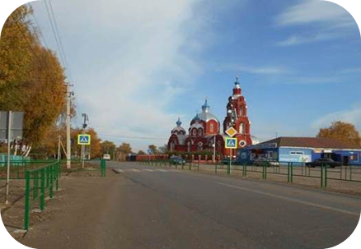 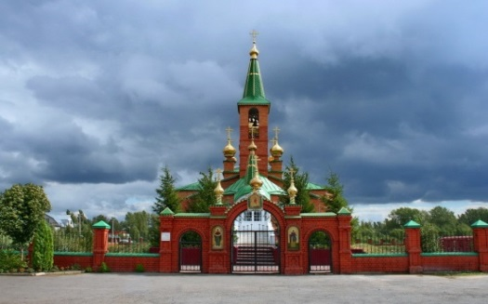

The most popular event in event tourism was the Bird in the Palm of Your Hand festival. The guests saw pigeons of different breeds, visited the fair and took part in competitions. The bright holiday united dozens of regions of Russia. 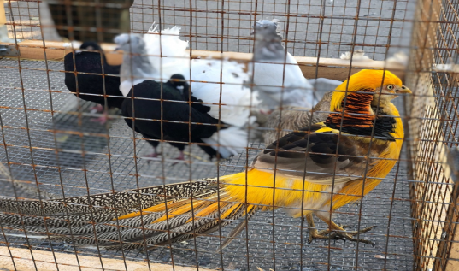

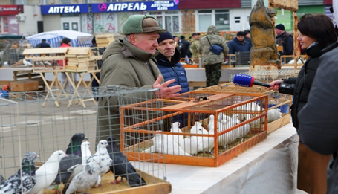 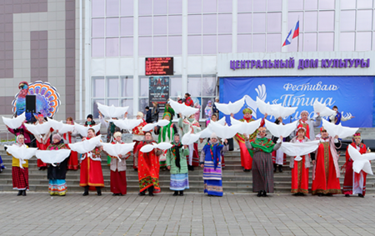

**4.7 List of the most significant enterprises**

|  |  |  |  |
| --- | --- | --- | --- |
| No.  p / p | Name | Number of employees | The main type of activity |
| 1 | Tambov Turkey LLC | 1872 | Agricultural industry |
| 2 | JSC "Khobotovskoye enterprise "Starch product" | 393 | Manufacturing |
| 3 | TOGAU "Khobotovsky forestry" | 64 | Forestry and other forestry activities |
| 4 | Agrofarm LLC | 80 | Manufacturing |
| 5 | Snezhetok LLC | 118 | Agricultural industry |
| 6 | Gazprom Transgaz Moscow LLC branch of Morshansk LPUMG Pervomaisky production site | 268 | Transportation and storage |

**5. Investment Advantages**

The favorable geographical location – the district is located on the border of three regions, the developed infrastructure is at the Bogoyavlenskoye junction station, the railway branches of the Paveletsky and Kazan directions converge, the federal highway M–6 passes through the district - all this combined makes Pervomaisky municipal district attractive to investors.

**6. Information on vacant land plots, unclaimed (partially in demand) industrial facilities suitable or partially suitable for the creation of investment sites and new production facilities on the territory of Pervomaisky municipal district.**

**Catalog of the investment platform No. 1**

|  |  |  |
| --- | --- | --- |
| 1. Location of the site | | 393711, Pervomaisky municipal district, Khobotets-Vasilyevskoye village |
| 2. Land category | | Agricultural land |
| 3. Area, ha | | 12,44 |
| 4. Form of ownership | | State property |
| 5. The possibility of expansion | | no |
| 6. Proposed directions Usage | | Agricultural purpose |
| 7. Availability of buildings and structures | | no |
| 8. | Availability of infrastructure and communications | Distance from the boundaries of the land plot (m) |
| Gas | 500 |
| Electric power | 600 |
| Water | 600 |
| Water disposal | - |
| The highway | 100 |

**Unified passport of the investment platform No. 1**

|  |  |  |  |  |  |  |  |  |  |  |  |  |  |  |  |  |  |
| --- | --- | --- | --- | --- | --- | --- | --- | --- | --- | --- | --- | --- | --- | --- | --- | --- | --- |
| **1. General information** | | | | | | | | | | | | | | | | | |
| 1.1. Type of site (brief description) | | | | | | | | | Land area with a total area of 12.44 hectares | | | | | | | | |
| 1.2. Cadastral number | | | | | | | | | 68:12:2202005:2 | | | | | | | | |
| 1.3. Form of ownership of land and buildings (ownership, lease, other) | | | | | | | | | State property | | | | | | | | |
| 1.4.Legal (postal) address, phone (area code), e-mail, website | | | | | | | | | 393711, Pervomaisky municipal district, Khobotets-Vasilyevskoye village | | | | | | | | |
| 1.5. Contact Person | | | | | | | | | Ryzhkov Roman Valerievich | | | | | | | | |
| 1.6. Position | | | | | | | | | The head of the district | | | | | | | | |
| 1.7. Phone number | | | | | | | | | 8(47548) 2-43-18; | | | | | | | | |
| 1.8 Fax | | | | | | | | | 8(47548) 2-44-25 | | | | | | | | |
| 1.9. E-mail | | | | | | | | | rrv777@mail.ru | | | | | | | | |
| 1.10. Website | | | | | | | | |  | | | | | | | | |
| **2. Location of the site** | | | | | | | | | | | | | | | | | |
| 2.1. The address of the site | | | | | | | | | | 393711, Pervomaisky municipal district, Khobotets-Vasilyevskoye village | | | | | | | |
| 2.2. Location on the territory of the current organization | | | | | | | | | | - | | | | | | | |
| 2.3. Within the city limits | | | | | | | | | | - | | | | | | | |
| 2.4. Distance from Tambov | | | | | | | | | | 110 km | | | | | | | |
| 2.5.In the protected area of cultural heritage sites (historical and cultural monuments), directly in cultural heritage sites | | | | | | | | | | - | | | | | | | |
| 2.6.Distance from the motorway, km | | | | | | | | | | 0,1 | | | | | | | |
| 2.7.Distance from the railway station, km | | | | | | | | | | 20 | | | | | | | |
| 2.8. Distance from the airport, km | | | | | | | | | | 110 | | | | | | | |
| 2.9.Nearby production facilities (industrial, agricultural, other) and the distance to them, km | | | | | | | | | | Agrofarm LLC - 5 | | | | | | | |
| 2.10.Distance to the nearest residential buildings, km | | | | | | | | | | 0,5 | | | | | | | |
| **3. Characteristics of the investment site** | | | | | | | | | | | | | | | | | |
| 3.1.Area, ha | | | | | | | | | | 12,44 | | | | | | | |
| 3.2.Availability of buildings and structures (list) | | | | | | | | | | no | | | | | | | |
| 3.3.The possibility of expansion | | | | | | | | | | no | | | | | | | |
| 3.4.Category of lands (agricultural lands; settlement lands; lands of industry, energy, transport, communications, radio broadcasting, television, computer science, lands for space activities, lands of defense, security and other special purpose lands; lands of specially protected natural territories and objects; lands of the forest fund; lands of the water fund; lands stock) | | | | | | | | | | Agricultural land | | | | | | | |
| 3.5.Functional area | | | | | | | | | | - | | | | | | | |
| 3.6.Presence of fences (yes, no) | | | | | | | | | | - | | | | | | | |
| 3.7.Relief, type of soil (flat, inclined, terraced, ledges) | | | | | | | | | | Smooth, loam | | | | | | | |
| 3.8. Current use of the site | | | | | | | | | | Not used | | | | | | | |
| 3.9.Intended uses | | | | | | | | | | Agricultural purpose | | | | | | | |
| **4. Infrastructure** | | | | | | | | | | | | | | | | | |  | |
| Resource | | Availability | | Unit of measurement | | Power | | The distance of the site from the source, m | | | | The possibility of increasing the power (up to) | | | The possibility of periodic shutdown | | |  |
| Water supply | | - | | cubic meters/year | | 8000 | | 100 | | | | 10000 | | |  | | |  |
| Electric power | | - | | kW | | 63 | | 700 | | | | 250 | | |  | | |  |
| Heating | | - | | Gcal/hour | | - | | - | | | | - | | |  | | |  |
| Sewage system | | - | | cubic meters/year | | - | | - | | | | - | | |  | | |  |
| Gas | | - | | cubic meters/year | | 320000 | | 500 | | | | 1500000 | | |  | | |  |
| Steam | | - | | Bar | | - | | - | | | | - | | |  | | |  |
| Sewage treatment plants | | - | | cubic meters/year | | - | | - | | | | - | | |  | | |  |
| Compressed air | | - | | cubic meters/year | | - | | - | | | | - | | |  | | |  |
| **5. Communications on the territory** | | | | | | | | | | | | | | | | | |  |
| 5.1.Highways (type, surface, length, etc.) | | | | | | | | | | | | | | | | | - |  |  | |
| 5.2.Railway line (type, coverage, length, etc.) | | | | | | | | | | | | | | | | | - |  |  | |
| 5.3.Telecommunication networks (telephone, Internet, other) | | | | | | | | | | | | | | | | | - |  |  | |
| **6. Buildings and structures on the territory** | | | | | | | | | | | | | | | | | |  | |  |
| The name of the object | Area,  sq. m | | Number of floors | | Ceiling height, m | | Type of structures, walls | | | | Degree of completion (% or otherwise) | | Degree of completion (% or otherwise) | | | How is it currently used (% or otherwise) | |  |  | |
|  |  | |  | |  | |  | | | |  | |  | | |  | |  |  | |
| **7. Labor resources** (population of the nearest settlements village of Khobotets - Vasilyevskoye | | | | | | | | | | | | | | | | | |  |  | |
| – 300 people) | | | | | | | | | | | | | | | | | |  |  | |
| **8. Terms of purchase (use) of the site** (purchase, lease, etc.) | | | | | | | | | | | | | | | | | |  |  | |
| 8.1.Terms of lease (purchase) of the plot | | | | | | | | | | | | | | - | | | |  |
| 8.2.Estimated rental cost | | | | | | | | | | | | | | - | | | |  |
| 8.3. Other costs associated with the acquisition of the site (topographic survey, preparation of a cadastral plan, surveying, etc.) | | | | | | | | | | | | | | - | | | |  |

**Catalog of the investment platform No. 2**

|  |  |  |
| --- | --- | --- |
| 1. Location of the site | | 393700, Tambov region, Pervomaisky municipal district, Pervomaisky settlement, Sovetskaya str., 2a |
| 2. Land category | | industrial |
| 3. Area, ha | | 4 |
| 4. Form of ownership | | private |
| 5. The possibility of expansion | | no |
| 6. Proposed directions Usage | | construction of an elevator and new agricultural facilities |
| 7. Availability of buildings and structures | | administrative building, warehouses |
| 8. | Availability of infrastructure and communications | yes |
| Gas | yes |
| Electric power | yes |
| Water | yes |
| Water disposal |  |
| The highway | yes |

**Unified passport of the investment site No**.**2**

|  |  |  |  |  |  |  |  |  |  |  |  |  |  |  |  |
| --- | --- | --- | --- | --- | --- | --- | --- | --- | --- | --- | --- | --- | --- | --- | --- |
| **1. General information** | | | | | | | | | | | | | | | |
| 1. General information | | | | | | | | | brownfield | | | | | | |
| 1.1. Type of site (brief description) | | | | | | | | | 68:12:0101005:31 | | | | | | |
| 1.2. Cadastral number | | | | | | | | | property | | | | | | |
| 1.3. Form of ownership of land and buildings (ownership, lease, other) | | | | | | | | | 393700, Tambov region, Pervomaisky municipal district, Pervomaisky  settlement, Sovetskaya str., 2a | | | | | | |
| 1.4.Legal (postal) address, phone (area code), e-mail, website | | | | | | | | | Bodrichenko Igor Alekseevich | | | | | | |
| 1.5. Contact Person | | | | | | | | | manager | | | | | | |
| 1.6. Position | | | | | | | | | 84959670200 | | | | | | |
| 1.7. Phone number | | | | | | | | |  | | | | | | |
| 1.8 Fax | | | | | | | | |  | | | | | | |
| 1.9. E-mail | | | | | | | | |  | | | | | | |
| 1.10. Website | | | | | | | | |  | | | | | | |
| **2. Location of the site** | | | | | | | | | | | | | | | |
| 2.1. The address of the site | | | | | | | | | 393700, Tambov region, Pervomaisky municipal district, Pervomaisky settlement, Sovetskaya str., 2a | | | | | | |
| 2.2. Location on the territory of the current organization | | | | | | | | |  | | | | | | |
| 2.3. Within the city limits | | | | | | | | | yes | | | | | | |
| 2.4. Distance from Tambov | | | | | | | | | 110 | | | | | | |
| 2.5.In the protected area of cultural heritage sites (historical and cultural monuments), directly in cultural heritage sites | | | | | | | | |  | | | | | | |
| 2.6.Distance from the motorway, km | | | | | | | | | 3 | | | | | | |
| 2.7.Distance from the railway station, km | | | | | | | | | 0,5 | | | | | | |
| 2.8. Distance from the airport, km | | | | | | | | | 110 | | | | | | |
| 2.9.Nearby production facilities (industrial, agricultural, other) and the distance to them, km | | | | | | | | | JSC "Pervomaiskkhimmash", LLC "Engineering" | | | | | | |
| 2.10.Distance to the nearest residential buildings, km | | | | | | | | | 0,1 | | | | | | |
| **3. Characteristics of the investment site** | | | | | | | | | | | | | | | |
| 3.1.Area, ha | | | | | | | | | 4 | | | | | | |
| 3.2.Availability of buildings and structures (list) | | | | | | | | | administrative building, warehouses | | | | | | |
| 3.3.The possibility of expansion | | | | | | | | | no | | | | | | |
| 3.4.Category of lands (agricultural lands; settlement lands; lands of industry, energy, transport, communications, radio broadcasting, television, computer science, lands for space activities, lands of defense, security and other special purpose lands; lands of specially protected natural territories and objects; lands of the forest fund; lands of the water fund; lands stock) | | | | | | | | | industrial lands | | | | | | |
| 3.5.Functional area | | | | | | | | |  | | | | | | |
| 3.6.Presence of fences (yes, no) | | | | | | | | | there is | | | | | | |
| 3.7.Relief, type of soil (flat, inclined, terraced, ledges) | | | | | | | | | smooth | | | | | | |
| 3.8. Current use of the site | | | | | | | | | not used | | | | | | |
| 3.9.Intended uses | | | | | | | | | construction of an elevator and new agricultural facilities | | | | | | |
| **4. Infrastructure** | | | | | | | | | | | | | | | |  |
| Resource | | Availability | | Unit of measurement | | Power | | The distance of the site from the source, m | | | The possibility of increasing the power (up to) | | The possibility of periodic shutdown | | |  |
| Water supply | | yes | | cubic meters/year | |  | |  | | |  | |  | | |  |
| Electric power | | yes | | kW | |  | |  | | |  | |  | | |  |
| Heating | | yes | | Gcal/hour | |  | |  | | |  | |  | | |  |
| Sewage system | | no | | cubic meters/year | |  | |  | | |  | |  | | |  |
| Gas | | yes | | cubic meters/year | |  | |  | | |  | |  | | |  |
| Steam | | no | | Bar | |  | |  | | |  | |  | | |  |
| Sewage treatment plants | | no | | cubic meters/year | |  | |  | | |  | |  | | |  |
| Compressed air | | no | | cubic meters/year | |  | |  | | |  | |  | | |  |
| **5. Communications on the territory** | | | | | | | | | | | | | | | |  |
| 5.1.Highways (type, surface, length, etc.) | | | | | | | | | | | | | | yes | |  |  |
| 5.2.Railway line (type, coverage, length, etc.) | | | | | | | | | | | | | | yes | |  |  |
| 5.3.Telecommunication networks (telephone, Internet, other) | | | | | | | | | | | | | | yes | |  |  |
| **6. Buildings and structures on the territory** | | | | | | | | | | | | | | | |  |  |
| The name of the object | Area,  sq. m | | Number of floors | | Ceiling height, m | | Type of structures, walls | | | Degree of completion (% or otherwise) | | Degree of completion (% or otherwise) | | | How is it currently used (% or otherwise) |  |  |
|  |  | |  | |  | |  | | |  | |  | | |  |  |  |
| **7. Labor resources** (population of the nearest settlements) | | | | | | | | | | | | | | | |  |  |
| of the Pervomaisky settlement, more than 5 thousand people | | | | | | | | | | | | | | | |  |  |
| **8. Terms of purchase (use) of the site** (purchase, lease, etc.) | | | | | | | | | | | | | | | |  |  |
| 8.1.Terms of lease (purchase) of the plot | | | | | | | | | | | | | |  | |  |
| 8.2.Estimated rental cost | | | | | | | | | | | | | |  | |  |
| 8.3. Other costs associated with the acquisition of the site (topographic survey, preparation of a cadastral plan, surveying, etc.) | | | | | | | | | | | | | |  | |  |

**Catalog of the investment platform No. 3**

|  |  |  |
| --- | --- | --- |
| 1. Location of the site | | 3937007, Tambov region, Pervomaisky Municipal District, Stepnaya str., 7 |
| 2. Land category | | industrial |
| 3. Area, ha | | 6,26 |
| 4. Form of ownership | | private |
| 5. The possibility of expansion | | no |
| 6. Proposed directions Usage | | food industry facility |
| 7. Availability of buildings and structures | | administrative building, workshops, warehouses, boiler room |
| 8. | Availability of infrastructure and communications | yes |
| Gas | yes |
| Electric power | yes |
| Water | yes |
| Water disposal | yes |
| The highway | yes |

**Unified passport of the investment site No. 3**

|  |  |  |  |  |  |  |  |  |  |  |  |  |  |  |  |  |
| --- | --- | --- | --- | --- | --- | --- | --- | --- | --- | --- | --- | --- | --- | --- | --- | --- |
|  | | | | | | | | | | | | | | | | |
| **1. General information** | | | | | | | | | | | | | | | | |
| 1.1. Type of site (brief description) | | | | | | | | brownfield | | | | | | | | |
| 1.2. Cadastral number | | | | | | | | 68:12:0101001:2 | | | | | | | | |
| 1.3. Form of ownership of land and buildings (ownership, lease, other) | | | | | | | | property | | | | | | | | |
| 1.4.Legal (postal) address, phone (area code), e-mail, website | | | | | | | | 3937007, Tambov region, Pervomaisky Municipal District, Stepnaya str., 7 | | | | | | | | |
| 1.5. Contact Person | | | | | | | | Savvateev Denis Sergeevich | | | | | | | | |
| 1.6. Position | | | | | | | | External manager | | | | | | | | |
| 1.7. Phone number | | | | | | | | 8(47545)23278 | | | | | | | | |
| 1.8 Fax | | | | | | | | 8(47545)23278 | | | | | | | | |
| 1.9. E-mail | | | | | | | | bux\_pmk@mail.ru, srp@mediaconsalt.ru | | | | | | | | |
| 1.10. Website | | | | | | | |  | | | | | | | | |
| **2. Location of the site** | | | | | | | | | | | | | | | | |
| 2.1. The address of the site | | | | | | | | 3937007, Tambov region, Pervomaisky Municipal District, Stepnaya str., 7 | | | | | | | | |
| 2.2. Location on the territory of the current organization | | | | | | | | no | | | | | | | | |
| 2.3. Within the city limits | | | | | | | | yes | | | | | | | | |
| 2.4. Distance from Tambov | | | | | | | | 110 км | | | | | | | | |
| 2.5.In the protected area of cultural heritage sites (historical and cultural monuments), directly in cultural heritage sites | | | | | | | |  | | | | | | | | |
| 2.6.Distance from the motorway, km | | | | | | | | 2,5 | | | | | | | | |
| 2.7.Distance from the railway station, km | | | | | | | | 0,5 | | | | | | | | |
| 2.8. Distance from the airport, km | | | | | | | | 110 | | | | | | | | |
| 2.9.Nearby production facilities (industrial, agricultural, other) and the distance to them, km | | | | | | | | JSC Pervomaiskkhimmash, Engineering LLC | | | | | | | | |
| 2.10.Distance to the nearest residential buildings, km | | | | | | | | 0,2 | | | | | | | | |
| **3. Characteristics of the investment site** | | | | | | | | | | | | | | | | |
| 3.1.Area, ha | | | | | | | | | | 6,26 | | | | | | |
| 3.2.Availability of buildings and structures (list) | | | | | | | | | | administrative building, workshops, warehouses, boiler room | | | | | | |
| 3.3.The possibility of expansion | | | | | | | | | | no | | | | | | |
| 3.4.Category of lands (agricultural lands; settlement lands; lands of industry, energy, transport, communications, radio broadcasting, television, computer science, lands for space activities, lands of defense, security and other special purpose lands; lands of specially protected natural territories and objects; lands of the forest fund; lands of the water fund; lands stock) | | | | | | | | | | industrial lands | | | | | | |
| 3.5.Functional area | | | | | | | | | |  | | | | | | |
| 3.6.Presence of fences (yes, no) | | | | | | | | | | there is | | | | | | |
| 3.7.Relief, type of soil (flat, inclined, terraced, ledges) | | | | | | | | | | smooth | | | | | | |
| 3.8. Current use of the site | | | | | | | | | | not used | | | | | | |
| 3.9.Intended uses | | | | | | | | | | food industry facility | | | | | | |
| **4. Infrastructure** | | | | | | | | | | | | | | | | |  |
| Resource | | Availability | | Unit of measurement | | Power | | | The distance of the site from the source, m | | | The possibility of increasing the power (up to) | | The possibility of periodic shutdown | | |  |
| Water supply | | yes | | cubic meters/year | |  | | |  | | |  | |  | | |  |
| Electric power | | yes | | kW | |  | | |  | | |  | |  | | |  |
| Heating | | yes | | Gcal/hour | |  | | |  | | |  | |  | | |  |
| Sewage system | | yes | | cubic meters/year | |  | | |  | | |  | |  | | |  |
| Gas | | yes | | cubic meters/year | |  | | |  | | |  | |  | | |  |
| Steam | | - | | Bar | |  | | |  | | |  | |  | | |  |
| Sewage treatment plants | | yes | | cubic meters/year | |  | | |  | | |  | |  | | |  |
| Compressed air | | - | | cubic meters/year | |  | | |  | | |  | |  | | |  |
| **5. Communications on the territory** | | | | | | | | | | | | | | | | |  |
| 5.1.Highways (type, surface, length, etc.) | | | | | | | | | | | | | | | yes | |  |  |
| 5.2.Railway line (type, coverage, length, etc.) | | | | | | | | | | | | | | | yes | |  |  |
| 5.3.Telecommunication networks (telephone, Internet, other) | | | | | | | | | | | | | | | yes | |  |  |
| **6. Buildings and structures on the territory** | | | | | | | | | | | | | | | | |  |  |
| The name of the object | Area,  sq. m | | Number of floors | | Ceiling height, m | | Type of structures, walls | | | | Degree of completion (% or otherwise) | | Degree of completion (% or otherwise) | | | How is it currently used (% or otherwise) |  |  |
|  |  | |  | |  | |  | | | |  | |  | | |  |  |  |
| **7. Labor resources** (population of the nearest settlements) | | | | | | | | | | | | | | | | |  |  |
| of the Pervomaisky settlement, more than 5 thousand people | | | | | | | | | | | | | | | | |  |  |
| **8. Terms of purchase (use) of the site** (purchase, lease, etc.) | | | | | | | | | | | | | | | | |  |  |
| 8.1.Terms of lease (purchase) of the plot | | | | | | | | | | | | | | |  | |  |
| 8.2.Estimated rental cost | | | | | | | | | | | | | | |  | |  |
| 8.3. Other costs associated with the acquisition of the site (topographic survey, preparation of a cadastral plan, surveying, etc.) | | | | | | | | | | | | | | |  | |  |

**Catalog of the investment platform No.4**

|  |  |  |
| --- | --- | --- |
| 1. Location of the site | | 393700, Tambov region, Pervomaisky municipal district, Pervomaisky settlement, Druzhby St., 40 meters west of house 4 |
| 2. Land category | | settlements |
| 3. Area, ha | | 0,6 |
| 4. Form of ownership | | state-owned |
| 5. The possibility of expansion | | no |
| 6. Proposed directions Usage | | Construction of apartment buildings |
| 7. Availability of buildings and structures | | no |
| 8. | Availability of infrastructure and communications | yes |
| Gas | yes |
| Electric power | yes |
| Water | yes |
| Water disposal | yes |
| The highway | yes |

**Unified passport of the investment site No.4**

|  |  |  |  |  |  |  |  |  |  |  |  |  |  |  |  |
| --- | --- | --- | --- | --- | --- | --- | --- | --- | --- | --- | --- | --- | --- | --- | --- |
| **1. General information** | | | | | | | | | | | | | | | |
|  | | | | | | | | | | | | | | | |
| 1.1. Type of site (brief description) | | | | | | | | | greenfield | | | | | | |
| 1.2. Cadastral number | | | | | | | | | 68:12:0101013:179 | | | | | | |
| 1.3. Form of ownership of land and buildings (ownership, lease, other) | | | | | | | | | state-owned | | | | | | |
| 1.4.Legal (postal) address, phone (area code), e-mail, website | | | | | | | | | 393700, Tambov region, Pervomaisky municipal district, Pervomaisky settlement, Druzhby St., 40 meters west of house 4 | | | | | | |
| 1.5. Contact Person | | | | | | | | | Ryzhkov Roman Valerievich | | | | | | |
| 1.6. Position | | | | | | | | | The head of the district | | | | | | |
| 1.7. Phone number | | | | | | | | | 8(47548) 2-43-18; | | | | | | |
| 1.8 Fax | | | | | | | | | 8(47548) 2-44-25 | | | | | | |
| 1.9. E-mail | | | | | | | | | rrv777@mail.ru | | | | | | |
| 1.10. Website | | | | | | | | |  | | | | | | |
| **2. Location of the site** | | | | | | | | | | | | | | | |
| 2.1. The address of the site | | | | | | | | | 393700, Tambov region, Pervomaisky municipal district, Pervomaisky settlement, Druzhby St., 40 meters west of house 4 | | | | | | |
| 2.2. Location on the territory of the current organization | | | | | | | | | no | | | | | | |
| 2.3. Within the city limits | | | | | | | | | yes | | | | | | |
| 2.4. Distance from Tambov | | | | | | | | | 110 | | | | | | |
| 2.5.In the protected area of cultural heritage sites (historical and cultural monuments), directly in cultural heritage sites | | | | | | | | |  | | | | | | |
| 2.6.Distance from the motorway, km | | | | | | | | | 2 | | | | | | |
| 2.7.Distance from the railway station, km | | | | | | | | | 1 | | | | | | |
| 2.8. Distance from the airport, km | | | | | | | | | 110 | | | | | | |
| 2.9.Nearby production facilities (industrial, agricultural, other) and the distance to them, km | | | | | | | | | JSC Pervomaiskkhimmash, Engineering LLC | | | | | | |
| 2.10.Distance to the nearest residential buildings, km | | | | | | | | | 0,2 | | | | | | |
| **3. Characteristics of the investment site** | | | | | | | | | | | | | | | |
| 3.1.Area, ha | | | | | | | | | 6,26 | | | | | | |
| 3.2.Availability of buildings and structures (list) | | | | | | | | | no | | | | | | |
| 3.3.The possibility of expansion | | | | | | | | | no | | | | | | |
| 3.4.Category of lands (agricultural lands; settlement lands; lands of industry, energy, transport, communications, radio broadcasting, television, computer science, lands for space activities, lands of defense, security and other special purpose lands; lands of specially protected natural territories and objects; lands of the forest fund; lands of the water fund; lands stock) | | | | | | | | | settlement lands | | | | | | |
| 3.5.Functional area | | | | | | | | |  | | | | | | |
| 3.6.Presence of fences (yes, no) | | | | | | | | | no | | | | | | |
| 3.7.Relief, type of soil (flat, inclined, terraced, ledges) | | | | | | | | | smooth | | | | | | |
| 3.8. Current use of the site | | | | | | | | |  | | | | | | |
| 3.9.Intended uses | | | | | | | | | construction of apartment buildings | | | | | | |
| **4. Infrastructure** | | | | | | | | | | | | | | | |  |
| Resource | | Availability | | Unit of measurement | | Power | | The distance of the site from the source, m | | | The possibility of increasing the power (up to) | | The possibility of periodic shutdown | | |  |
| Water supply | | yes | | cubic meters/year | |  | |  | | |  | |  | | |  |
| Electric power | | yes | | kW | |  | |  | | |  | |  | | |  |
| Heating | | yes | | Gcal/hour | |  | |  | | |  | |  | | |  |
| Sewage system | | yes | | cubic meters/year | |  | |  | | |  | |  | | |  |
| Gas | | yes | | cubic meters/year | |  | |  | | |  | |  | | |  |
| Steam | | - | | Bar | |  | |  | | |  | |  | | |  |
| Sewage treatment plants | | - | | cubic meters/year | |  | |  | | |  | |  | | |  |
| Compressed air | | - | | cubic meters/year | |  | |  | | |  | |  | | |  |
| **5. Communications on the territory** | | | | | | | | | | | | | | | |  |
| 5.1.Highways (type, surface, length, etc.) | | | | | | | | | | | | | | yes | |  |  |
| 5.2.Railway line (type, coverage, length, etc.) | | | | | | | | | | | | | | yes | |  |  |
| 5.3.Telecommunication networks (telephone, Internet, other) | | | | | | | | | | | | | | yes | |  |  |
| **6. Buildings and structures on the territory** | | | | | | | | | | | | | | | |  |  |
| The name of the object | Area,  sq. m | | Number of floors | | Ceiling height, m | | Type of structures, walls | | | Degree of completion (% or otherwise) | | Degree of completion (% or otherwise) | | | How is it currently used (% or otherwise) |  |  |
| missing | | | | | | | | | | | | | | | |  |  |  |  |  |  |  |
| **7**. **Labor resources** (population of the nearest settlements) | | | | | | | | | | | | | | | |  |  |
| of the Pervomaisky settlement, more than 5 thousand people | | | | | | | | | | | | | | | |  |  |
| **8. Terms of purchase (use) of the site** (purchase, lease, etc.) | | | | | | | | | | | | | | | |  |  |
| 8.1.Terms of lease (purchase) of the plot | | | | | | | | | | | | | |  | |  |
| 8.2.Estimated rental cost | | | | | | | | | | | | | |  | |  |
| 8.3. Other costs associated with the acquisition of the site (topographic survey, preparation of a cadastral plan, surveying, etc.) | | | | | | | | | | | | | |  | |  |

**Catalog of the investment platform No.5**

|  |  |  |
| --- | --- | --- |
| 1. Location of the site | | 393700, Tambov region, Pervomaisky district, Sovetskaya Street, 215a |
| 2. Land category | | settlements |
| 3. Area, ha | | 0,2825 |
| 4. Form of ownership | | municipal |
| 5. The possibility of expansion | | no |
| 6. Proposed directions Usage | | the object of motor transport services |
| 7. Availability of buildings and structures | | administrative building, garages |
| 8. | Availability of infrastructure and communications | yes |
| Gas | yes |
| Electric power | yes |
| Water |  |
| Water disposal |  |
| The highway | yes |

**Unified passport of the investment site No.5**

|  |  |  |
| --- | --- | --- |
| **1. General information** | | |
| 1.1. Type of site (brief description) | brownfield | |
| 1.2. Cadastral number | 68:12:0101022:106 | |
| 1.3. Form of ownership of land and buildings (ownership, lease, other) | municipal | |
| 1.4.Legal (postal) address, phone (area code), e-mail, website | 393700, Tambov region, Pervomaisky district, Sovetskaya Street, 215a | |
| 1.5. Contact Person | Ryzhkov Roman Valerievich | |
| 1.6. Position | The head of the district | |
| 1.7. Phone number | 8(47548) 2-43-18; | |
| 1.8 Fax | 8(47548) 2-44-25 | |
| 1.9. E-mail | rrv777@mail.ru | |
| 1.10. Website |  | |
| **2. Location of the site** | | |
| 2.1. The address of the site | 393700, Tambov region, Pervomaisky district, Sovetskaya Street, 215a | |
| 2.2. Location on the territory of the current organization | no | |
| 2.3. Within the city limits | yes | |
| 2.4. Distance from Tambov | 110 km | |
| 2.5.In the protected area of cultural heritage sites (historical and cultural monuments), directly in cultural heritage sites |  | |
| 2.6.Distance from the motorway, km | 3 | |
| 2.7.Distance from the railway station, km | 1,5 | |
| 2.8. Distance from the airport, km | 110 | |
| 2.9.Nearby production facilities (industrial, agricultural, other) and the distance to them, km | JSC Pervomaiskkhimmash, Engineering LLC | |
| 2.10.Distance to the nearest residential buildings, km | 0,5 | |
| **3. Characteristics of the investment site** | | |
| 3.1.Area, ha | 0,2825 | |
| 3.2.Availability of buildings and structures (list) | administrative building, garages | |
| 3.3.The possibility of expansion | no | |
| 3.4.Category of lands (agricultural lands; settlement lands; lands of industry, energy, transport, communications, radio broadcasting, television, computer science, lands for space activities, lands of defense, security and other special purpose lands; lands of specially protected natural territories and objects; lands of the forest fund; lands of the water fund; lands stock) | lands of industry, energy, transport, communications, radio broadcasting, television, computer science, lands for space activities, lands of defense, security and other special purposes; lands of specially protected natural territories and facilities; lands of the forest fund; lands of the water fund; reserve lands) | |
| 3.5.Functional area |  | |
| 3.6.Presence of fences (yes, no) | yes | |
| 3.7.Relief, type of soil (flat, inclined, terraced, ledges) | smooth | |
| 3.8. Current use of the site | not used | |
| 3.9.Intended uses | the object of motor transport services | |
| **4. Infrastructure** | | |
| |  |  |  |  |  |  |  |  |  |  |  |  |  |  |  |  | | --- | --- | --- | --- | --- | --- | --- | --- | --- | --- | --- | --- | --- | --- | --- | --- | | Resource | | Availability | | Unit of measurement | | Power | | The distance of the site from the source, m | | The possibility of increasing the power (up to) | | | The possibility of periodic shutdown | |  | | Water supply | | yes | | cubic meters/year | |  | |  | |  | | |  | |  | | Electric power | | yes | | kW | |  | |  | |  | | |  | |  | | Heating | | yes | | Gcal/hour | |  | |  | |  | | |  | |  | | Sewage system | |  | | cubic meters/year | |  | |  | |  | | |  | |  | | Gas | | yes | | cubic meters/year | |  | |  | |  | | |  | |  | | Steam | |  | | Bar | |  | |  | |  | | |  | |  | | Sewage treatment plants | |  | | cubic meters/year | |  | |  | |  | | |  | |  | | Compressed air | |  | | cubic meters/year | |  | |  | |  | | |  | |  | | **5. Communications on the territory** | | | | | | | | | | | | | | |  | | 5.1.Highways (type, surface, length, etc.) | | | | | | | | | | | | yes | | |  |  | | 5.2.Railway line (type, coverage, length, etc.) | | | | | | | | | | | | yes | | |  |  | | 5.3.Telecommunication networks (telephone, Internet, other) | | | | | | | | | | | | yes | | |  |  | | **6. Buildings and structures on the territory** | | | | | | | | | | | | | | |  |  | | The name of the object | Area,  sq. m | | Number of floors | | Ceiling height, m | | Type of structures, walls | | Degree of completion (% or otherwise) | | Degree of completion (% or otherwise) | | | How is it currently used (% or otherwise) |  |  | | | |  |
| **7**. **Labor resources** (population of the nearest settlements) | | |
| of the Pervomaisky settlement, more than 5 thousand people | | |
| **8. Terms of purchase (use) of the site** (purchase, lease, etc.) | | |
| 8.1.Terms of lease (purchase) of the plot | |  |
| 8.2.Estimated rental cost | |  |
| 8.3. Other costs associated with the acquisition of the site (topographic survey, preparation of a cadastral plan, surveying, etc.) | |  |

**Catalog of the investment platform No.6**

|  |  |  |
| --- | --- | --- |
| 1. Location of the site | | 393700, Tambov region, Pervomaisky municipal district, 343 km of the Moscow-Volgograd highway, gas station No. 74 |
| 2. Land category | | lands of industry, energy, transport, communications, radio broadcasting, television, computer science, lands for space activities, lands of defense, security and other special purpose lands |
| 3. Area, ha | | 1,6083 |
| 4. Form of ownership | | private |
| 5. The possibility of expansion | | no |
| 6. Proposed directions Usage | | providing road recreation |
| 7. Availability of buildings and structures | | Cafe, hotel, gazebo |
| 8. | Availability of infrastructure and communications | yes |
| Gas | no |
| Electric power | yes |
| Water | yes |
| Water disposal | yes |
| The highway | yes |

**Unified passport of the investment site No.6**

|  |  |  |  |  |  |  |  |  |  |  |  |  |  |  |  |
| --- | --- | --- | --- | --- | --- | --- | --- | --- | --- | --- | --- | --- | --- | --- | --- |
| **1. General information** | | | | | | | | | | | | | | | |
| 1.1. Type of site (brief description) | | | | | | | | | brownfield | | | | | | |
| 1.2. Cadastral number | | | | | | | | | 68:12:1401001:4 | | | | | | |
| 1.3. Form of ownership of land and buildings (ownership, lease, other) | | | | | | | | | individual ownership | | | | | | |
| 1.4.Legal (postal) address, phone (area code), e-mail, website | | | | | | | | | 393700, Tambov region, Pervomaisky municipal district, 343 km of the Moscow-Volgograd highway (Damansky complex) | | | | | | |
| 1.5. Contact Person | | | | | | | | | Gabueva Galina Vladimirovna | | | | | | |
| 1.6. Position | | | | | | | | | copyright holder | | | | | | |
| 1.7. Phone number | | | | | | | | | 8(47548) 2- 33 -50 | | | | | | |
| 1.8 Fax | | | | | | | | |  | | | | | | |
| 1.9. E-mail | | | | | | | | |  | | | | | | |
| 1.10. Website | | | | | | | | |  | | | | | | |
| **2. Location of the site** | | | | | | | | | | | | | | | |
| 2.1. The address of the site | | | | | | | | | 393700, Tambov region, Pervomaisky municipal district, 343 km of the Moscow-Volgograd highway, gas station No. 74 | | | | | | |
| 2.2. Location on the territory of the current organization | | | | | | | | | no | | | | | | |
| 2.3. Within the city limits | | | | | | | | | no | | | | | | |
| 2.4. Distance from Tambov | | | | | | | | | 135 | | | | | | |
| 2.5.In the protected area of cultural heritage sites (historical and cultural monuments), directly in cultural heritage sites | | | | | | | | |  | | | | | | |
| 2.6.Distance from the motorway, km | | | | | | | | |  | | | | | | |
| 2.7.Distance from the railway station, km | | | | | | | | | 25 | | | | | | |
| 2.8. Distance from the airport, km | | | | | | | | | 135 | | | | | | |
| 2.9.Nearby production facilities (industrial, agricultural, other) and the distance to them, km | | | | | | | | | Tambov Turkey LLC | | | | | | |
| 2.10.Distance to the nearest residential buildings, km | | | | | | | | | 1 | | | | | | |
| **3. Characteristics of the investment site** | | | | | | | | | | | | | | | |
| 3.1.Area, ha | | | | | | | | | 1,6083 | | | | | | |
| 3.2.Availability of buildings and structures (list) | | | | | | | | | Coffee, hotel, gazebo | | | | | | |
| 3.3.The possibility of expansion | | | | | | | | | no | | | | | | |
| 3.4.Category of lands (agricultural lands; settlement lands; lands of industry, energy, transport, communications, radio broadcasting, television, computer science, lands for space activities, lands of defense, security and other special purpose lands; lands of specially protected natural territories and objects; lands of the forest fund; lands of the water fund; lands stock) | | | | | | | | | lands of industry, energy, transport, communications, radio broadcasting, television, computer science, lands for space activities, lands of defense, security and other special purpose lands; lands of specially protected natural territories and facilities | | | | | | |
| 3.5.Functional area | | | | | | | | |  | | | | | | |
| 3.6.Presence of fences (yes, no) | | | | | | | | | no | | | | | | |
| 3.7.Relief, type of soil (flat, inclined, terraced, ledges) | | | | | | | | | smooth | | | | | | |
| 3.8. Current use of the site | | | | | | | | | not used | | | | | | |
| 3.9.Intended uses | | | | | | | | | providing road recreation | | | | | | |
| **4. Infrastructure** | | | | | | | | | | | | | | | |  |
| Resource | | Availability | | Unit of measurement | | Power | | The distance of the site from the source, m | | | The possibility of increasing the power (up to) | | The possibility of periodic shutdown | | |  |
| Water supply | | yes | | cubic meters/year | |  | |  | | |  | |  | | |  |
| Electric power | | yes | | kW | |  | |  | | |  | |  | | |  |
| Heating | | yes | | Gcal/hour | |  | |  | | |  | |  | | |  |
| Sewage system | | yes | | cubic meters/year | |  | |  | | |  | |  | | |  |
| Gas | |  | | cubic meters/year | |  | |  | | |  | |  | | |  |
| Steam | |  | | Bar | |  | |  | | |  | |  | | |  |
| Sewage treatment plants | |  | | cubic meters/year | |  | |  | | |  | |  | | |  |
| Compressed air | |  | | cubic meters/year | |  | |  | | |  | |  | | |  |
| **5. Communications on the territory** | | | | | | | | | | | | | | | |  |
| 5.1.Highways (type, surface, length, etc.) | | | | | | | | | | | | | | yes | |  |  |
| 5.2.Railway line (type, coverage, length, etc.) | | | | | | | | | | | | | |  | |  |  |
| 5.3.Telecommunication networks (telephone, Internet, other) | | | | | | | | | | | | | | yes | |  |  |
| **6. Buildings and structures on the territory** | | | | | | | | | | | | | | | |  |  |
| The name of the object | Area,  sq. m | | Number of floors | | Ceiling height, m | | Type of structures, walls | | | Type of structures, walls | | Degree of completion (% or otherwise) | | | How is it currently used (% or otherwise) |  |  |
|  |  | |  | |  | |  | | |  | |  | | |  |  |  |
| **7. Labor resources** (population of the nearest settlements | | | | | | | | | | | | | | | |  |  |
| of Novoarkhangelskoye village, 600 people | | | | | | | | | | | | | | | |  |  |
| **8. Terms of purchase (use) of the site** (purchase, lease, etc.) | | | | | | | | | | | | | | | |  |  |
| 8.1.Terms of lease (purchase) of the plot | | | | | | | | | | | | | |  | |  |
| 8.2.Estimated rental cost | | | | | | | | | | | | | |  | |  |
| 8.3. Other costs associated with the acquisition of the site (topographic survey, preparation of a cadastral plan, surveying, etc.) | | | | | | | | | | | | | |  | |  |

**Catalog of the investment platform No.7**

|  |  |  |
| --- | --- | --- |
| 1. Location of the site | | 393700, Tambov region, Pervomaisky municipal district, 343 km of the Moscow-Volgograd highway |
| 2. Land category | | lands of industry, energy, transport, communications, radio broadcasting, television, computer science, lands for space activities, lands of defense, security and other special purpose lands |
| 3. Area, ha | | 0,117 |
| 4. Form of ownership | | private |
| 5. The possibility of expansion | | no |
| 6. Proposed directions Usage | | providing road recreation |
| 7. Availability of buildings and structures | |  |
| 8. | Availability of infrastructure and communications | yes |
| Gas |  |
| Electric power | yes |
| Water | yes |
| Water disposal |  |
| The highway | yes |

**Unified passport of the investment site No.7**

|  |  |  |  |  |  |  |  |  |  |  |  |  |  |  |  |
| --- | --- | --- | --- | --- | --- | --- | --- | --- | --- | --- | --- | --- | --- | --- | --- |
| **1. General information** | | | | | | | | | | | | | | | |
| 1.1. Type of site (brief description) | | | | | | | | | brownfield | | | | | | |
| 1.2. Cadastral number | | | | | | | | | 68:12:1401001:3 | | | | | | |
| 1.3. Form of ownership of land and buildings (ownership, lease, other) | | | | | | | | |  | | | | | | |
| 1.4.Legal (postal) address, phone (area code), e-mail, website | | | | | | | | | 393700, Tambov region, Pervomaisky municipal district, 343 km of the Moscow-Volgograd highway (Damansky complex) | | | | | | |
| 1.5. Contact Person | | | | | | | | | Gabueva Galina Vladimirovna | | | | | | |
| 1.6. Position | | | | | | | | | copyright holder | | | | | | |
| 1.7. Phone number | | | | | | | | | 8(47548) 2- 33 -50 | | | | | | |
| 1.8 Fax | | | | | | | | |  | | | | | | |
| 1.9. E-mail | | | | | | | | |  | | | | | | |
| 1.10. Website | | | | | | | | |  | | | | | | |
|  | | | | | | | | | | | | | | | |
| **2. Location of the site** | | | | | | | | | | | | | | | |
| 2.1. The address of the site | | | | | | | | | 393700, Tambov region, Pervomaisky municipal district, 343 km of the Moscow-Volgograd highway (Damansky complex) | | | | | | |
| 2.2. Location on the territory of the current organization | | | | | | | | |  | | | | | | |
| 2.3. Within the city limits | | | | | | | | |  | | | | | | |
| 2.4. Distance from Tambov | | | | | | | | | 135 | | | | | | |
| 2.5.In the protected area of cultural heritage sites (historical and cultural monuments), directly in cultural heritage sites | | | | | | | | |  | | | | | | |
| 2.6.Distance from the motorway, km | | | | | | | | |  | | | | | | |
| 2.7.Distance from the railway station, km | | | | | | | | | 25 | | | | | | |
| 2.8. Distance from the airport, km | | | | | | | | | 135 | | | | | | |
| 2.9.Nearby production facilities (industrial, agricultural, other) and the distance to them, km | | | | | | | | | Tambov Turkey LLC | | | | | | |
| 2.10.Distance to the nearest residential buildings, km | | | | | | | | | 1 | | | | | | |
| **3. Characteristics of the investment site** | | | | | | | | | | | | | | | |
| 3.1.Area, ha | | | | | | | | | 0,117 | | | | | | |
| 3.2.Availability of buildings and structures (list) | | | | | | | | |  | | | | | | |
| 3.3.The possibility of expansion | | | | | | | | | no | | | | | | |
| 3.4.Category of lands (agricultural lands; settlement lands; lands of industry, energy, transport, communications, radio broadcasting, television, computer science, lands for space activities, lands of defense, security and other special purpose lands; lands of specially protected natural territories and objects; lands of the forest fund; lands of the water fund; lands stock) | | | | | | | | | lands of industry, energy, transport, communications, radio broadcasting, television, computer science, lands for space activities, lands of defense, security and other special purpose lands; lands of specially protected natural territories and facilities | | | | | | |
| 3.5.Functional area | | | | | | | | |  | | | | | | |
| 3.6.Presence of fences (yes, no) | | | | | | | | | there is | | | | | | |
| 3.7.Relief, type of soil (flat, inclined, terraced, ledges) | | | | | | | | | smooth | | | | | | |
| 3.8. Current use of the site | | | | | | | | |  | | | | | | |
| 3.9.Intended uses | | | | | | | | | providing road recreation | | | | | | |
| **4. Infrastructure** | | | | | | | | | | | | | | | |  |
| Resource | | Availability | | Unit of measurement | | Power | | The distance of the site from the source, m | | | The possibility of increasing the power (up to) | | The possibility of periodic shutdown | | |  |
| Water supply | | yes | | cubic meters/year | |  | |  | | |  | |  | | |  |
| Electric power | | yes | | kW | |  | |  | | |  | |  | | |  |
| Heating | | yes | | Gcal/hour | |  | |  | | |  | |  | | |  |
| Sewage system | | yes | | cubic meters/year | |  | |  | | |  | |  | | |  |
| Gas | |  | | cubic meters/year | |  | |  | | |  | |  | | |  |
| Steam | |  | | Bar | |  | |  | | |  | |  | | |  |
| Sewage treatment plants | |  | | cubic meters/year | |  | |  | | |  | |  | | |  |
| Compressed air | |  | | cubic meters/year | |  | |  | | |  | |  | | |  |
| **5. Communications on the territory** | | | | | | | | | | | | | | | |  |
| 5.1.Highways (type, surface, length, etc.) | | | | | | | | | | | | | | yes | |  |  |
| 5.2.Railway line (type, coverage, length, etc.) | | | | | | | | | | | | | |  | |  |  |
| 5.3.Telecommunication networks (telephone, Internet, other) | | | | | | | | | | | | | | yes | |  |  |
| **6. Buildings and structures on the territory** | | | | | | | | | | | | | | | |  |  |
| The name of the object | Area,  sq. m | | Number of floors | | Ceiling height, m | | Type of structures, walls | | | Type of structures, walls | | Degree of completion (% or otherwise) | | | How is it currently used (% or otherwise) |  |  |
|  |  | |  | |  | |  | | |  | |  | | |  |  |  |
| **7. Labor resources** (population of the nearest settlements | | | | | | | | | | | | | | | |  |  |
| of Novoarkhangelskoye village, 600 people | | | | | | | | | | | | | | | |  |  |
| **8. Terms of purchase (use) of the site** (purchase, lease, etc.) | | | | | | | | | | | | | | | |  |  |
| 8.1.Terms of lease (purchase) of the plot | | | | | | | | | | | | | |  | |  |
| 8.2.Estimated rental cost | | | | | | | | | | | | | |  | |  |
| 8.3. Other costs associated with the acquisition of the site (topographic survey, preparation of a cadastral plan, surveying, etc.) | | | | | | | | | | | | | |  | |  |

**Catalog of the investment site No.8**

|  |  |  |
| --- | --- | --- |
| 1. Location of the site | | Tambov region, Pervomaisky municipal district, rural settlement - Khobotovo settlement, Lesnaya Street, land plot 1b |
| 2. Land category | | Lands of settlements |
| 3. Area, ha | | 5,0 |
| 4. Form of ownership | | State non-delimited property |
| 5. The possibility of expansion | | no |
| 6. Proposed directions Usage | | Travel services |
| 7. Availability of buildings and structures | | no |
| 8. | Availability of infrastructure and communications | no |
| Gas | no |
| Electric power | no |
| Water | no |
| Water disposal | no |
| The highway |  |

**Unified passport of the investment platform No.8**

|  |  |  |  |  |  |  |  |  |  |  |  |  |  |  |  |  |  |
| --- | --- | --- | --- | --- | --- | --- | --- | --- | --- | --- | --- | --- | --- | --- | --- | --- | --- |
| **1. General information** | | | | | | | | | | | | | | | | | |
| 1.1. Type of site (brief description) | | | | | | | | | greenfield | | | | | | | | |
| 1.2. Cadastral number | | | | | | | | | 68:12:0901004:364 | | | | | | | | |
| 1.3. Form of ownership of land and buildings (ownership, lease, other) | | | | | | | | |  | | | | | | | | |
| 1.4.Legal (postal) address, phone (area code), e-mail, website | | | | | | | | | Tambov region, Pervomaisky municipal district, rural settlement - Khobotovo settlement, Lesnaya Street, land plot 1b | | | | | | | | |
| 1.5. Contact Person | | | | | | | | | Ryzhkov Roman Valerievich | | | | | | | | |
| 1.6. Position | | | | | | | | | The head of the district | | | | | | | | |
| 1.7. Phone number | | | | | | | | | 8(47548) 2-43-18; | | | | | | | | |
| 1.8 Fax | | | | | | | | | 8(47548) 2-44-25 | | | | | | | | |
| 1.9. E-mail | | | | | | | | | rrv777@mail.ru | | | | | | | | |
| 1.10. Website | | | | | | | | |  | | | | | | | | |
| **2. Location of the site** | | | | | | | | | | | | | | | | | |
| 2.1. The address of the site | | | | | | | | | | Tambov region, Pervomaisky municipal district, rural settlement - Khobotovo settlement, Lesnaya Street, land plot 1b | | | | | | | |
| 2.2. Location on the territory of the current organization | | | | | | | | | |  | | | | | | | |
| 2.3. Within the city limits | | | | | | | | | |  | | | | | | | |
| 2.4. Distance from Tambov | | | | | | | | | | 80 km | | | | | | | |
| 2.5.In the protected area of cultural heritage sites (historical and cultural monuments), directly in cultural heritage sites | | | | | | | | | |  | | | | | | | |
| 2.6.Distance from the motorway, km | | | | | | | | | | 5 | | | | | | | |
| 2.7.Distance from the railway station, km | | | | | | | | | | 2 | | | | | | | |
| 2.8. Distance from the airport, km | | | | | | | | | | 80 | | | | | | | |
| 2.9.Nearby production facilities (industrial, agricultural, other) and the distance to them, km | | | | | | | | | | TOGAU "Khobotovsky forestry" | | | | | | | |
| 2.10.Distance to the nearest residential buildings, km | | | | | | | | | | 2 | | | | | | | |
| **3. Characteristics of the investment site** | | | | | | | | | | | | | | | | | |
| 3.1.Area, ha | | | | | | | | | | 5 | | | | | | | |
| 3.2.Availability of buildings and structures (list) | | | | | | | | | | no | | | | | | | |
| 3.3.The possibility of expansion | | | | | | | | | | no | | | | | | | |
| 3.4.Category of lands (agricultural lands; settlement lands; lands of industry, energy, transport, communications, radio broadcasting, television, computer science, lands for space activities, lands of defense, security and other special purpose lands; lands of specially protected natural territories and objects; lands of the forest fund; lands of the water fund; lands stock) | | | | | | | | | | Lands of settlements | | | | | | | |
| 3.5.Functional area | | | | | | | | | | - | | | | | | | |
| 3.6.Presence of fences (yes, no) | | | | | | | | | | no | | | | | | | |
| 3.7.Relief, type of soil (flat, inclined, terraced, ledges) | | | | | | | | | | Smooth, loam | | | | | | | |
| 3.8. Current use of the site | | | | | | | | | | not used | | | | | | | |
| 3.9.Intended uses | | | | | | | | | | Travel services | | | | | | | |
| **4. Infrastructure** | | | | | | | | | | | | | | | | | |  | |
| Resource | | Availability | | Unit of measurement | | Power | | The distance of the site from the source, m | | | | The possibility of increasing the power (up to) | | | The possibility of periodic shutdown | | |  |
| Water supply | | no | | cubic meters/year | |  | |  | | | |  | | |  | | |  |
| Electric power | | no | | kW | |  | |  | | | |  | | |  | | |  |
| Heating | | no | | Gcal/hour | |  | |  | | | |  | | |  | | |  |
| Sewage system | | no | | cubic meters/year | |  | |  | | | |  | | |  | | |  |
| Gas | | no | | cubic meters/year | |  | |  | | | |  | | |  | | |  |
| Steam | | no | | Bar | |  | |  | | | |  | | |  | | |  |
| Sewage treatment plants | | no | | cubic meters/year | |  | |  | | | |  | | |  | | |  |
| Compressed air | | no | | cubic meters/year | |  | |  | | | |  | | |  | | |  |
| **5. Communications on the territory** | | | | | | | | | | | | | | | | | |  |
| 5.1.Highways (type, surface, length, etc.) | | | | | | | | | | | | | | | | |  |  |  | |
| 5.2.Railway line (type, coverage, length, etc.) | | | | | | | | | | | | | | | | |  |  |  | |
| 5.3.Telecommunication networks (telephone, Internet, other) | | | | | | | | | | | | | | | | |  |  |  | |
| **6. Buildings and structures on the territory** | | | | | | | | | | | | | | | | | |  | |  |
| The name of the object | Area,  sq. m | | Number of floors | | Ceiling height, m | | Type of structures, walls | | | | Degree of completion (% or otherwise) | | Degree of completion (% or otherwise) | | | How is it currently used (% or otherwise) | |  |  | |
|  |  | |  | |  | |  | | | |  | |  | | |  | |  |  | |
| **7. Labor resources** (the population of the nearest settlements of the village | | | | | | | | | | | | | | | | | |  |  | |
| of Khobotovo is 1.45 thousand people). | | | | | | | | | | | | | | | | | |  |  | |
| **8. Terms of purchase (use) of the site (purchase, lease, etc.)** | | | | | | | | | | | | | | | | | |  |  | |
| 8.1.Terms of lease (purchase) of the plot | | | | | | | | | | | | | |  | | | |  |
| 8.2.Estimated rental cost | | | | | | | | | | | | | |  | | | |  |
| 8.3. Other costs associated with the acquisition of the site (topographic survey, preparation of a cadastral plan, surveying, etc.) | | | | | | | | | | | | | |  | | | |  |

**Catalog of the investment platform No.9**

|  |  |  |
| --- | --- | --- |
| 1. Location of the site | | 393709, Tambov region, Pervomaisky municipal district, Chernyshevsky village Council, land plot No. 13 |
| 2. Land category | | agricultural purposes |
| 3. Area, ha | | 158 |
| 4. Form of ownership | | State unrestricted property |
| 5. The possibility of expansion | | no |
| 6. Proposed directions Usage | | Land plot |
| 7. Availability of buildings and structures | | no |
| 8. | Availability of infrastructure and communications | no |
| Gas | no |
| Electric power | no |
| Water | no |
| Water disposal | no |
| The highway | no |

**Unified passport of the investment platform No.9**

|  |  |  |  |  |  |  |  |  |  |  |  |  |  |  |  |  |
| --- | --- | --- | --- | --- | --- | --- | --- | --- | --- | --- | --- | --- | --- | --- | --- | --- |
| **1. General information** | | | | | | | | | | | | | | | | |
| 1.1. Type of site (brief description) | | | | | | | | | greenfield | | | | | | | |
| 1.2. Cadastral number | | | | | | | | | 68:12:2502007:3 | | | | | | | |
| 1.3. Form of ownership of land and buildings (ownership, lease, other) | | | | | | | | |  | | | | | | | |
| 1.4.Legal (postal) address, phone (area code), e-mail, website | | | | | | | | | 393709, Tambov region, Pervomaisky municipal district, Chernyshevsky village Council, land plot No. 13 | | | | | | | |
| 1.5. Contact Person | | | | | | | | | Ryzhkov Roman Valerievich | | | | | | | |
| 1.6. Position | | | | | | | | | The head of the district | | | | | | | |
| 1.7. Phone number | | | | | | | | | 8(47548) 2-43-18; | | | | | | | |
| 1.8 Fax | | | | | | | | | 8(47548) 2-44-25 | | | | | | | |
| 1.9. E-mail | | | | | | | | | rrv777@mail.ru | | | | | | | |
| 1.10. Website | | | | | | | | |  | | | | | | | |
| **2. Location of the site** | | | | | | | | | | | | | | | | |
| 2.1. The address of the site | | | | | | | | | 393709, Tambov region, Pervomaisky municipal district, Chernyshevsky village Council, land plot No. 13 | | | | | | | |
| 2.2. Location on the territory of the current organization | | | | | | | | |  | | | | | | | |
| 2.3. Within the city limits | | | | | | | | | no | | | | | | | |
| 2.4. Distance from Tambov | | | | | | | | | 120 | | | | | | | |
| 2.5.In the protected area of cultural heritage sites (historical and cultural monuments), directly in cultural heritage sites | | | | | | | | | no | | | | | | | |
| 2.6.Distance from the motorway, km | | | | | | | | | 12 | | | | | | | |
| 2.7.Distance from the railway station, km | | | | | | | | | 18 | | | | | | | |
| 2.8. Distance from the airport, km | | | | | | | | | 120 | | | | | | | |
| 2.9.Nearby production facilities (industrial, agricultural, other) and the distance to them, km | | | | | | | | | the rearing workshop Tambov Turkey LLC | | | | | | | |
| 2.10.Distance to the nearest residential buildings, km | | | | | | | | | 3 | | | | | | | |
| **3. Characteristics of the investment site** | | | | | | | | | | | | | | | | |
| 3.1.Area, ha | | | | | | | | | 158 | | | | | | | |
| 3.2.Availability of buildings and structures (list) | | | | | | | | | no | | | | | | | |
| 3.3.The possibility of expansion | | | | | | | | | no | | | | | | | |
| 3.4.Category of lands (agricultural lands; settlement lands; lands of industry, energy, transport, communications, radio broadcasting, television, computer science, lands for space activities, lands of defense, security and other special purpose lands; lands of specially protected natural territories and objects; lands of the forest fund; lands of the water fund; lands stock) | | | | | | | | | agricultural lands | | | | | | | |
| 3.5.Functional area | | | | | | | | |  | | | | | | | |
| 3.6.Presence of fences (yes, no) | | | | | | | | | no | | | | | | | |
| 3.7.Relief, type of soil (flat, inclined, terraced, ledges) | | | | | | | | | smooth | | | | | | | |
| 3.8. Current use of the site | | | | | | | | |  | | | | | | | |
| 3.9.Intended uses | | | | | | | | | Land plot | | | | | | | |
| **4. Infrastructure** | | | | | | | | | | | | | | | | |  |
| Resource | | Availability | | Unit of measurement | | Power | | The distance of the site from the source, m | | | The possibility of increasing the power (up to) | | The possibility of periodic shutdown | | | |  |
| Water supply | | no | | cubic meters/year | |  | |  | | |  | |  | | | |  |
| Electric power | | no | | kW | |  | |  | | |  | |  | | | |  |
| Heating | | no | | Gcal/hour | |  | |  | | |  | |  | | | |  |
| Sewage system | | no | | cubic meters/year | |  | |  | | |  | |  | | | |  |
| Gas | | no | | cubic meters/year | |  | |  | | |  | |  | | | |  |
| Steam | | no | | Bar | |  | |  | | |  | |  | | | |  |
| Sewage treatment plants | | no | | cubic meters/year | |  | |  | | |  | |  | | | |  |
| Compressed air | | no | | cubic meters/year | |  | |  | | |  | |  | | | |  |
| **5. Communications on the territory** | | | | | | | | | | | | | | | | |  |
| 5.1.Highways (type, surface, length, etc.) | | | | | | | | | | | | | | | | no |  |  |
| 5.2.Railway line (type, coverage, length, etc.) | | | | | | | | | | | | | | | | no |  |  |
| 5.3.Telecommunication networks (telephone, Internet, other) | | | | | | | | | | | | | | | | no |  |  |
| **6. Buildings and structures on the territory** | | | | | | | | | | | | | | | | |  |  |
| The name of the object | Area,  sq. m | | Number of floors | | Ceiling height, m | | Type of structures, walls | | | Degree of completion (% or otherwise) | | Degree of completion (% or otherwise) | | | How is it currently used (% or otherwise) | |  |  |
|  |  | |  | |  | |  | | |  | |  | | |  | |  |  |
| 7. Labor resources (the population of the nearest settlements | | | | | | | | | | | | | | | | |  |  |
| of Chernyshevka village, 147 people | | | | | | | | | | | | | | | | |  |  |
| **8. Terms of purchase (use) of the site** (purchase, lease, etc.) | | | | | | | | | | | | | | | | |  |  |
| 8.1.Terms of lease (purchase) of the plot | | | | | | | | | | | | | |  | | |  |
| 8.2.Estimated rental cost | | | | | | | | | | | | | |  | | |  |
| 8.3. Other costs associated with the acquisition of the site (topographic survey, preparation of a cadastral plan, surveying, etc.) | | | | | | | | | | | | | |  | | |  |

**Catalog of the investment platform No.10**

|  |  |  |
| --- | --- | --- |
| 1. Location of the site | | 393709, Tambov region, Pervomaisky municipal district, Chernyshevsky village Council, land plot No. 9 |
| 2. Land category | | agricultural purposes |
| 3. Area, ha | | 115,6 |
| 4. Form of ownership | | State unrestricted property |
| 5. The possibility of expansion | | no |
| 6. Proposed directions Usage | | Land plot |
| 7. Availability of buildings and structures | | no |
| 8. | Availability of infrastructure and communications | no |
| Gas | no |
| Electric power | no |
| Water | no |
| Water disposal | no |
| The highway | no |

**Unified passport of the investment platform No.10**

|  |  |  |  |  |  |  |  |  |  |  |  |  |  |  |  |  |
| --- | --- | --- | --- | --- | --- | --- | --- | --- | --- | --- | --- | --- | --- | --- | --- | --- |
|  | | | | | | | | | | | | | | | | |
| **1. General information** | | | | | | | | | | | | | | | | |
| 1.1. Type of site (brief description) | | | | | | | | | greenfield | | | | | | | |
| 1.2. Cadastral number | | | | | | | | | 68:12:2502003:4 | | | | | | | |
| 1.3. Form of ownership of land and buildings (ownership, lease, other) | | | | | | | | |  | | | | | | | |
| 1.4.Legal (postal) address, phone (area code), e-mail, website | | | | | | | | | 393709, Tambov region, Pervomaisky municipal district, Chernyshevsky village Council, land plot No. 9 | | | | | | | |
| 1.5. Contact Person | | | | | | | | | Ryzhkov Roman Valerievich | | | | | | | |
| 1.6. Position | | | | | | | | | The head of the district | | | | | | | |
| 1.7. Phone number | | | | | | | | | 8(47548) 2-43-18; | | | | | | | |
| 1.8 Fax | | | | | | | | | 8(47548) 2-44-25 | | | | | | | |
| 1.9. E-mail | | | | | | | | | rrv777@mail.ru | | | | | | | |
| 1.10. Website | | | | | | | | |  | | | | | | | |
| **2. Location of the site** | | | | | | | | | | | | | | | | |
| 2.1. The address of the site | | | | | | | | | 393709, Tambov region, Pervomaisky municipal district, Chernyshevsky village Council, land plot No. 9 | | | | | | | |
| 2.2. Location on the territory of the current organization | | | | | | | | |  | | | | | | | |
| 2.3. Within the city limits | | | | | | | | | no | | | | | | | |
| 2.4. Distance from Tambov | | | | | | | | | 120 | | | | | | | |
| 2.5.In the protected area of cultural heritage sites (historical and cultural monuments), directly in cultural heritage sites | | | | | | | | |  | | | | | | | |
| 2.6.Distance from the motorway, km | | | | | | | | | 12 | | | | | | | |
| 2.7.Distance from the railway station, km | | | | | | | | | 18 | | | | | | | |
| 2.8. Distance from the airport, km | | | | | | | | | 130 | | | | | | | |
| 2.9.Nearby production facilities (industrial, agricultural, other) and the distance to them, km | | | | | | | | | the rearing workshop Tambov Turkey LLC | | | | | | | |
| 2.10.Distance to the nearest residential buildings, km | | | | | | | | | 3 | | | | | | | |
|  | | | | | | | | | | | | | | | | |
| **3. Characteristics of the investment site** | | | | | | | | | | | | | | | | |
| 3.1.Area, ha | | | | | | | | | 115,6 | | | | | | | |
| 3.2.Availability of buildings and structures (list) | | | | | | | | | no | | | | | | | |
| 3.3.The possibility of expansion | | | | | | | | | no | | | | | | | |
| 3.4.Category of lands (agricultural lands; settlement lands; lands of industry, energy, transport, communications, radio broadcasting, television, computer science, lands for space activities, lands of defense, security and other special purpose lands; lands of specially protected natural territories and objects; lands of the forest fund; lands of the water fund; lands stock) | | | | | | | | | agricultural lands | | | | | | | |
| 3.5.Functional area | | | | | | | | |  | | | | | | | |
| 3.6.Presence of fences (yes, no) | | | | | | | | | no | | | | | | | |
| 3.7.Relief, type of soil (flat, inclined, terraced, ledges) | | | | | | | | | smooth | | | | | | | |
| 3.8. Current use of the site | | | | | | | | |  | | | | | | | |
| 3.9.Intended uses | | | | | | | | | Land plot | | | | | | | |
| **4. Infrastructure** | | | | | | | | | | | | | | | | |  |
| Resource | | Availability | | Unit of measurement | | Power | | The distance of the site from the source, m | | | The possibility of increasing the power (up to) | | The possibility of periodic shutdown | | | |  |
| Water supply | | no | | cubic meters/year | |  | |  | | |  | |  | | | |  |
| Electric power | | no | | kW | |  | |  | | |  | |  | | | |  |
| Heating | | no | | Gcal/hour | |  | |  | | |  | |  | | | |  |
| Sewage system | | no | | cubic meters/year | |  | |  | | |  | |  | | | |  |
| Gas | | no | | cubic meters/year | |  | |  | | |  | |  | | | |  |
| Steam | | no | | Bar | |  | |  | | |  | |  | | | |  |
| Sewage treatment plants | | no | | cubic meters/year | |  | |  | | |  | |  | | | |  |
| Compressed air | | no | | cubic meters/year | |  | |  | | |  | |  | | | |  |
| **5. Communications on the territory** | | | | | | | | | | | | | | | | |  |
| 5.1.Highways (type, surface, length, etc.) | | | | | | | | | | | | | | | | no |  |  |
| 5.2.Railway line (type, coverage, length, etc.) | | | | | | | | | | | | | | | | no |  |  |
| 5.3.Telecommunication networks (telephone, Internet, other) | | | | | | | | | | | | | | | | no |  |  |
| **6. Buildings and structures on the territory** | | | | | | | | | | | | | | | | |  |  |
| The name of the object | Area,  sq. m | | Number of floors | | Ceiling height, m | | Type of structures, walls | | | Degree of completion (% or otherwise) | | Degree of completion (% or otherwise) | | | How is it currently used (% or otherwise) | |  |  |
|  |  | |  | |  | |  | | |  | |  | | |  | |  |  |
| **7. Labor resources** (the population of the nearest settlements | | | | | | | | | | | | | | | | |  |  |
| of Chernyshevka village, 147 people | | | | | | | | | | | | | | | | |  |  |
| **8. Terms of purchase (use) of the site** (purchase, lease, etc.) | | | | | | | | | | | | | | | | |  |  |
| 8.1.Terms of lease (purchase) of the plot | | | | | | | | | | | | | |  | | |  |
| 8.2.Estimated rental cost | | | | | | | | | | | | | |  | | |  |
| 8.3. Other costs associated with the acquisition of the site (topographic survey, preparation of a cadastral plan, surveying, etc.) | | | | | | | | | | | | | |  | | |  |

7. MANAGEMENT AND CONTACTS

**Head of district administration**

RYZHKOV ROMAN VALERYEVICH

Phone / Fax: (47548) 2-43-18; (47548) 2-44-25

E-mail: rrv777@mail.ru

**Deputy heads of the district administration:**

ABAKAROV ABAKAR TEMIRBULATOVICH

Phone/Fax number: (47548) 2-41- 57; (47548) 2-44-25

E-mail: aat2025@r48.tambov.gov.ru

**Deputy heads of the district administration:**

ALYMOVA TATYANA ANATOLYEVNA

Phone /Fax: (47548) 2-11-40; (47548) 2-44-25

E-mail:obraz1@r48.tambov.gov.ru

**Deputy heads of the district administration:**

KNYAZKOV YURI MIKHAILOVICH

Phone / Fax: (47548) 2-43-48; (47548) 2-44-25

E-mail: nnn2017@r48.tambov.gov.ru

**Deputy heads of the district administration:**

MAHINA IRAIDA VALERYEVNA

Phone / Fax: (47548) 2-11-93; (47548) 2-44-25

E-mail:[miv@r48.tambov.gov.ru](mailto:miv@r48.tambov.gov.ru)